MUNICIPAL REFORM IS THE KEY TO RECOVERY AND SUCCESS
New Brunswickers know that the Province’s situation is unsustainable. This COVID crisis is but the latest in a series of stresses on our hospital-centric health care system and the coming reductions in Federal transfer payments will eliminate all hope of continued public debt reduction. Such issues are not news to New Brunswickers – our situation is characterized by indecision, not ignorance. As always, the question is where to begin. At the core of New Brunswick’s predicament is the misalignment of administrative structures with the communities of interest that have developed in this Province. New Brunswick’s people, infrastructure, and economic forces have integrated themselves into a number of natural but informal regions with shared interests and challenges, but the political structures which New Brunswickers have inherited do not reflect these social and economic realities. Before New Brunswick can begin to address its other problems, we must get out house in order. To be effective, our government must be organized to reflect the New Brunswick of today, not yesterday.
Examples of the misalignment of administrative structures with the needs of New Brunswick’s regional communities can be found throughout the Province. In health care, the misalignment is visible in the operation of multiple hospitals within a region whose population does not warrant it while the funds are needed elsewhere. In local government, it is the refusal of neighboring communities to collaborate on service provision and cost sharing. In order to end the fragmentation of service provision and decision-making, New Brunswick must modernize its local governance system to reflect both local and regional needs. By formalizing these regions through municipal reform, New Brunswick can begin to plan and manage on a regional basis for better outcomes for all. No more artificial barriers between populations whose interests are basically identical. Rebuilding our local government system from the ground up with a view to local, regional, and ultimately Provincial self-reliance is the key to restoring hope, ensuring recovery, and enabling future prosperity.
Challenges for Local and Provincial Governments
Living so close to Prince Edward Island can skew our sense of size, but it is worth reminding ourselves that New Brunswick is a small place. In theory, the management of less than 800,000 people in 73,000 km² should be relatively straightforward. However, New Brunswick’s diversity and the isolation of some of its population hubs make the direct management of Provincial government inappropriate in many contexts. Essential services like land use planning, fire suppression, road maintenance, and policing are services best organized and delivered locally or regionally. Tailoring these services to community needs requires a level of familiarity impossible at the Provincial level. The challenge for New Brunswick is therefore giving communities the tools they need to govern themselves without making these local governments too small to support themselves.
For the size of its population, New Brunswick’s local governance system is incredibly fragmented. Compared with Nova Scotia which has a total of 50 local governance entities, New Brunswick is home to nearly 400 local governance entities including Cities, Towns, Villages, Rural Communities, Regional Municipalities, Local Service Districts and more. New Brunswick is also subdivided by both Provincial and Federal departments and agencies. Because funding for public projects is often provided by multiple levels of government, these conflicting divisions fragment decision-making even further. The result is that while New Brunswick does have identifiable regions with shared interests, the administration of these areas is so complicated that coordinated efforts for change are almost impossible. Rather than attempting to slowly merge various communities and encourage voluntary cost-sharing initiatives between municipalities as we have done in recent decades, we need to implement a system that can decisively identify and formalize the communities of interest and regions which have already developed on their own.
Resistance to Change
While there will always be resistance to change, the reality is that the current system of local governance is disadvantageous for all. Most of the Province’s territory is made up of Local Service Districts (LSDs) with some essential services like policing and road maintenance provided directly by the Provincial government. Residents of these unincorporated areas have no elected representatives and no power to determine the cost or quality of these services. The cost of such services is actually far greater than the property taxes collected by the Province to fund them, meaning that the current system serves to normalize both democratic and financial deficits. While these low property tax rates are currently a selling point for LSDs, the lack of local representation means that if tax increases were proposed, LSDs would have no way to dispute these increases. Therefore, despite the initial appeal of lower property tax rates, it is evident that the current system unfairly deprives residents of LSDs of important democratic rights.
The remainder of the Province is made up of municipalities and rural communities, many of which are struggling because of the system’s disregard for regional interdependence. Because the Province’s social and economic structures have naturally inclined towards regional integration around economic hubs, the cities that provide the economic stimulus for the surrounding region are burdened with spillover costs. Residents from neighboring communities continually use city infrastructure without contributing to the maintenance of these services. The tax efforts of these cities are further harmed by residents moving to suburban bedroom communities to evade the high property tax rates of economic hubs. The term bedroom community comes from the fact that while residents live in these smaller suburban communities, they are almost exclusively employed in the economic hub. This situation is common across the Province.
Likewise, the Province’s rural town and villages are also losing residents to suburban communities. Decreasing populations in the province’s smallest towns and villages harm both democratic health and service capacity. As fewer people live in and contribute to the community, the community becomes less able to provide quality services which causes even more people move away. These migrations demonstrate both the relevance of regional communities of interest and the inefficient use of money which results from a misalignment of boundaries. Were services provided on a more regional basis, many of these rural populations would be well cared for. It is the fragmentation of these communities which causes them to become unviable.
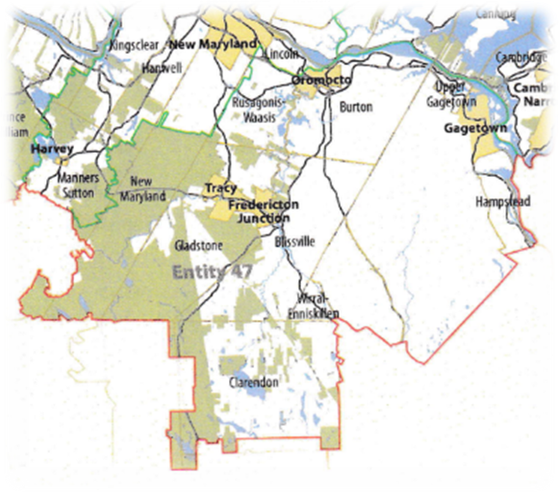

A New Framework
The Province must therefore pursue a reform agenda which incorporates the entire territory, creates municipalities which reflect existing communities of interest rather than historical boundaries, and mandates that these new entities collaborate on select services on a regional basis. These reforms would give local representation to the third of the Province’s population currently living in unincorporated areas for the first time since the abolition of County government. Municipal reform would also ensure that property taxes correlate with the services residents actually use, creating a fairer system for all. Most importantly, reform would encourage cost-sharing and economic planning on a truly regional basis, making the tax dollars that are collected more effective in the long run.
In practical terms, these changes would result in the replacement of the hundreds of local governance entities with just 53 new municipalities. Each municipality would have population and financial bases big enough to provide all the services required of a city or town and more, but still be small enough to represent local interests. The 53 municipalities would also be grouped into 12 new Regional Service Districts. These regional bodies would be made up of representatives from each member municipality and would facilitate shared policing, emergency measures planning, economic development, solid waste disposal, and community planning across an entire region. While significantly larger than most municipalities existing in New Brunswick today, these communities would still be smaller than those in other parts of Canada and roughly equivalent to those found in Nova Scotia.
Further Benefits
By formalizing the Province’s regions and economic hubs through municipal reform, the Province would also be well positioned to move forward with transformations of other public sectors. The recent collapse of the government’s attempt at modifications to the health system failed in large part because of a lack of community information and engagement in the effected regions. With universal local representation and formalized regional representation, the implementation of health reform could be more easily accomplished and would better reflect the needs of New Brunswickers. While the operations of public health are totally separate from those of local governments, local representatives nonetheless must play an important role in communicating the needs of the community to Provincial service providers as they make life altering decisions.
Regionalization could also be an important step toward creating alternative forms of community policing. Recently there have been calls from across the United States and Canada for dramatic changes to policing. The limited financial capacities of New Brunswick’s existing local governments make police reform difficult to pursue. Many communities are too small to support local police forces, leading to policing being contracted to the RCMP. While cost effective, such contracting does not allow for the sort of imaginative and community-oriented transformation desired by many. Regionalized service provision would enable New Brunswickers to create new local police forces or policing alternatives at a level that is both accountable and cost-effective.

Call to Action
New Brunswickers are leaving money on the table. The complicated and overlapping administrative boundaries of local, provincial, and federal governments which claim to serve the same area complicate service delivery and more importantly, prevent necessary changes to the system. By mandating that the essential services appropriate to local government be provided by local governments, public service will be more accountable. By providing services like policing and garbage disposal on a regional basis, the same services will be both universal and cost-effective. The regional framework developed for local government can also serve as a basis for future reorganization of other provincial services. There is no sacrifice in municipal reform, only a recognition of what can be gained. While we cannot control the global forces which act upon us, we can ensure that our own house is in order and make the most of what we have.
For more information on the specifics of municipal reform in New Brunswick, see the CCC’s website. Online you will find our complete report as well as written briefs describing each of the 53 proposed entities.
We are drowning in unnecessary complexity and inefficiency. The lifeboats are all around us in the form of better organization. All we need to do is to see them and jump on board. First, we need to let go of the water logs that have jammed the system for years. We call upon all New Brunswickers to walk with faith and encourage our politicians to get on with the job.

