An Image of the Future – Entity 10 and Regional Service District 3
To illustrate the benefits of this new framework, take the example of Entity 10, the municipality roughly equivalent with Beresford parish. For the duration of this discussion the municipality shall be referred to as Entity 10, as while the municipality could conceivably adopt the name Beresford or any other name, the naming of the 53 municipal entities remains a task for the citizens of each entity. Leaving the name of each entity undetermined is an important measure for the development of sustainable new municipal identities to compliment the pre-existing community identities of the affected towns, villages and LSDs.
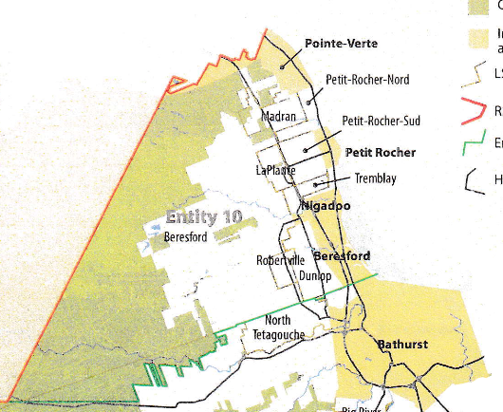
Entity 10 is a logical example to begin with as four of the municipalities extant within its boundaries have a history of collaboration in the delivery of services. Beresford, Nigadoo, Petit-Rocher, and Pointe-Verte are all served by one local police force, a relatively unique approach to policing in the province as for the most part policing remains planned and organized on a local/municipal basis.
Geographic Boundaries
In addition to the four aforementioned communities, Entity 10 would also include the LSDs of Madron, Petit-Rocher-Nord, Petit-Rocher-Sud, LaPlante, Tremblay, Robertville, Dunlop, and Beresford Parish. While the largest extant municipality is Beresford, the remaining municipalities are all fairly similar in size and are settled along the coast. The only areas along the coast currently unincorporated are the LSDs of Petit-Rocher-Nord and Petit-Rocher-Sud, and while both entities are smaller than their incorporated neighbors, these two jurisdictions are also the only two areas in the boundaries of Entity 7 to have reported population growth from 2011-2015. Despite the existing municipal boundaries then, the area along the coast is continuously inhabited, providing a settlement pattern conducive to collaboration and unification.
While lacking a boundary as natural as a coastline, the remaining borders of Entity 10 nonetheless attempt to draw upon pre-established divisions and frontiers. From the coast, the North-Western boundary of Entity 10 would follow the boundaries of Pointe-Verte and the Beresford Parish LSD. To the South, however, the boundary would correlate with the northern edge of North Tetagouche LSD, the edge of Crown lands extending from the Bereford Parish LSD into the Bathurst Parish LSD, and Route 180. These boundaries would encompass the major population centers of the Bereford Parish LSD and follow pre-established and familiar, albeit modified, boundary markers.
Demographic Base
The total population of the municipality would be approximately 14000, a number which has remained relatively stable from 2011-2016. The population would be overwhelmingly francophone, with only 10% of the population being anglophones. In accordance with the Official Languages Act, Entity 10 would therefore not be required to operate bilingually.
In accordance with the aims of the new framework, this increase in overall population will reduce the area’s democratic deficit, bringing representative local government to over 6000 residents of the entity’s current LSDs and enabling more competitive municipal elections.
Despite having the democratic institutions appropriate to a community, in 2018 Point-Verte elected at least one councilor in a by-election by acclamation, and all four incorporated communities reported lower voter turnout rates than the provincial average in the 2016 quadrennial municipal elections. By contrast, recently incorporated areas such as the relatively novel Rural Communities, being given a representative local government for the first time since the 1960s, have reported higher than average voter turnout rates with the exceptions of Hanwell and Campobello. The average rate across all 7 communities was 55.42%, but the highest among the class, Kedgwick, had a turnout rate of 73.69%! It could be anticipated, therefore, that the currently unincorporated areas of Entity 10 would bring a good deal of competition to the municipality’s elections, guaranteeing a vibrant democratic community.
These LSDs will not, however, be underrepresented. In order to strike a balance between local and municipal-wide interests, councillors should be elected based on a mixed system of wards and at-large with each councillor representing a relatively comparable number of residents. As with the name of each of entity, however, the exact composition of ward boundaries and council size will be left to the entities themselves to determine. Given the mix of rural, urban, and suburban populations to be merged in Entity 10, some circumstances may inspire the creation of specific wards to address the particular concerns of different populations and areas. However, it is recommended that wards for the new entity should not vary by more than 25 per cent from the average ward population to ensure a degree of balance on the municipal council. Furthermore, it is recommended that these ward boundaries intentionally disregard former municipal boundaries so as to avoid promoting division along the lines of previously existing local governance entities. The goal is ultimately to encourage a strong and active democratic community, not exacerbate differences.
Financial Base
Entity 10 will also have a financial base capable of service provision beyond a simple aggregation of the assessed value of each constituent municipality and LSD. Under the new framework, municipal revenues will come from a combination of equalization payments from the provincial government, municipal property taxes, and other user fees related to services like water and wastewater usage.
Because its population is above 10000, Entity 10 would qualify as a ‘Group B’ municipality. As its property assessment base per capita would be lesser than the group average, the entity would receive an annual equalization grant of $4,132,443 to ensure equal opportunity among the 53 municipal entities. With the tax room transfer from the provincial government to municipal governments included in the proposed new framework, Entity 10’s assessment base of $765,925,800 would be able to yield more revenue than it could under the current local governance regime. Equal Opportunity among municipalities remains a priority in the new framework, but the primary guarantor of said equality is now tax warrants rather than equalization payments.
Of course, this tax room transfer does not necessitate that property tax rates will increase by $1.50 per $100 of valuation across Entity 10, nor does it indicate that the entire municipality will operate with one universal property tax rate. Because Entity 10 would be composed of urban, suburban and rural populations and since the level of local services may vary considerably within the same municipality, existing provisions regarding differentiated tax rates within the same municipality would need to be used. Residents within each municipality should be taxed for the level of services they receive.
As has been seen in many municipalities around the province, municipalities can adopt differing tax rates for different areas under their jurisdiction. For example, in 2014 four LSDs merged with the neighboring village of Eel River Crossing. While the town’s tax property tax rate in 2018 was $1.32 per $100, each former LSD had different lower property tax rates appropriate to their circumstances. Similar situations can be found across the province, with some cities even imposing different tax rates for those inside and outside the urban center. As the communities within Entity 10 move forward together, then, it is entirely possible that each former local governance entity maintain their own respective property tax regimes, though strict adherence to such a scheme would fail to take advantage of the opportunities offered by their amalgamation. Overall, then, Entity 10 would have a financial base appropriate to its size and population.
Municipal and Provincial Responsibilities
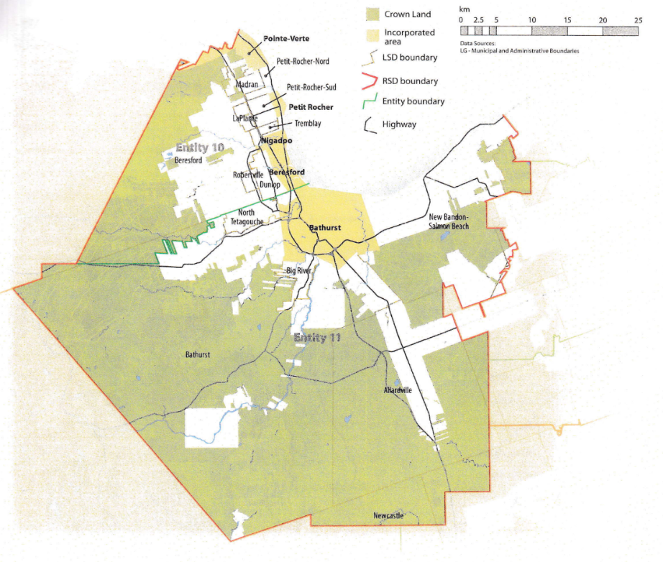
In addition to policing, emergency measures planning, fire prevention and suppression, roads, and garbage disposal, a municipality may choose to enlarge its role and provide a great number of other services. Many municipalities also take responsibility for local arts and culture, parks and recreation, public transportation, and more. Whether or not this sort of expansion is done is entirely up to the residents of Entity 10, and the tax rates of the entity would reflect this level of service.
Many of these services, however, would be better provided at the regional rather than local level. Rather than leaving some services in the care of the province, the new framework provides Regional Service Districts within which municipalities can collaborate on such basic services as policing, waste management, and land-use planning. Collaboration on these issues will further reduce cost for services, allowing property tax rates to remain at a reasonable rate.
Entity 10 would therefore share a number of responsibilities such as solid waste disposal, economic development, and policing with its neighbour Entity 11 through Regional Service District 3. As with each municipal entity, RSDs could conceivably be named, but this would be left to each community to determine for itself. Both entities would be equal partners in the provision of regional services, with each having a comparable demographic and tax base. While this region is far too large to be incorporated into a single municipality, the populations nonetheless have a great deal of shared experiences and challenges. The RSD can therefore help address common economic and service related challenges without compromising the self-governance of any contingent entity.
Overall, however, the new framework would clarify the distinction between municipal and provincial responsibilities. While today the service provision of roads, animal control, and policing is dependent on whether or not you live in an incorporated or unincorporated local governance entity, in the new framework, all of these services will be provided by the municipal government. When the residents know exactly who is accountable for what, services will improve.
Summation
Though a motion to annex the LSDs of Petit-Rocher-Nord, Petit-Rocher-Sud, Tremblay, Laplante, Madran and a portion of the parish of Beresford to the village of Petit-Rocher was voted down by the citizens of these LSDs in May of 2015, the benefits of joining a larger municipality like that described above should hopefully be clear. While the annexation of these communities into one larger entity may not have been desirable at the time, the resources and opportunities offered in this framework should represent a different enough proposal that a potential merger should be reconsidered by these residents.
Overall, Entity 10 would allow all residents of the Beresford parish to enjoy a comparable level of service in correlation with their level of taxation, to feel represented at a local level and have a real say in how their property tax dollars are being spent, and create a municipal entity that is sustainable enough to navigate the demographic and economic challenges of the 21st century.

Finn, 181.
Finn, 32.
Finn, 106.
https://www.electionsnb.ca/content/dam/enb/pdf/2018MunEventsRpt..PDF, i.
https://www.electionsnb.ca/content/dam/enb/pdf/2016-05-09-Municipal.pdf
Finn, 80-81.
Finn, 91.
Finn, 90.

