An Image of the Future – Entity 11 and Regional Service District 3
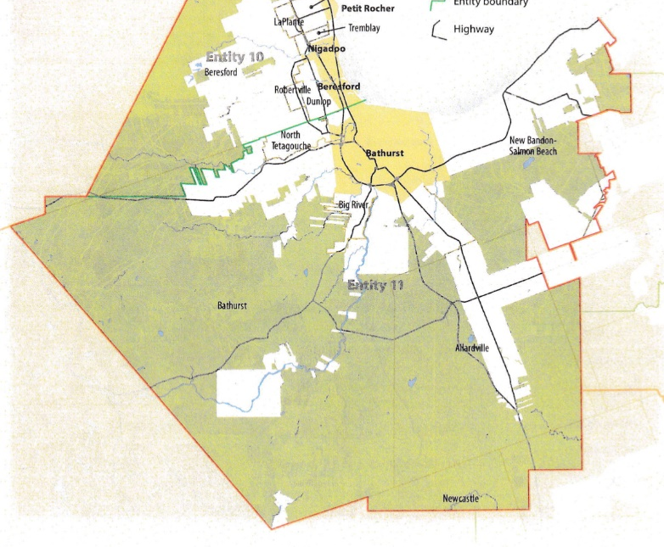
To illustrate the benefits of this new framework, take the example of Entity 11, the municipality roughly equivalent to Bathurst and the surrounding area. For the duration of this discussion the municipality shall be referred to as Entity 11, as while the municipality could conceivably adopt the name Bathurst, the naming of the 53 municipal entities remains a task for the citizens of each entity. Leaving the name of each entity undetermined is an important measure for the development of sustainable new municipal identities which complement the existing community identities.
Geographic Boundaries
Entity 11 would be comprised of the city of Bathurst and the surrounding LSDs of North Tetagouche, Big River, New Bandon-Salmon Beach, Bathurst Parish, Allardville, along with a sliver of Newcastle. In practical terms, Entity 11 therefore represents the incorporation of Bathurst’s periphery; all communities whose populations are already intertwined with their hub city and who benefit from their proximity to it.
Entity 11’s northern boundary would be the coast, with its northwestern edge following the parish lines with the exception of the Crown lands extending from the Beresford Parish LSD into the Bathurst Parish LSD, and Route 180. It’s southern boundaries would roughly correlate with the Bathurst and Allardville LSDs, though with some minor discrepancies such as the inclusion of the northernmost tip of Newcastle LSD. Its eastern boundary would the borders of New Bandon-Salmon Beach and Allardville, with the exclusion of the Saint-Sauveur LSD. These boundaries would encompass the major population centers of the greater Bathurst area and follow pre-established and familiar, albeit modified, boundary markers.
Demographic Base
The total population of the municipality would be approximately 19500, a 3% reduction from 2011-2016. The population would be linguistically balanced, with anglophones representing 45% of the population. In accordance with the Official Languages Act, Entity 11 would therefore be required to operate bilingually. Much of this language balance would seem to come from the dominance of Bathurst over the region, but this is not the case. Though the city of Bathurst does have a roughly equal divide between English and French, the bilingual governance of Entity 11 is of benefit to all of its composite communities. Bathurst Parish is just as linguistically balanced as the city of Bathurst, and while New Bandon-Salmon Beach and Allardville are each linguistically homogeneous, one is English and the other is French. Bilingual governance is therefore entirely appropriate for Entity 11.
In accordance with the aims of the new framework, this increase in overall population will reduce the area’s democratic deficit, bringing representative local government to over 7600 residents of the entity’s current LSDs and enabling more competitive municipal elections.
The city of Bathurst, the only incorporated area and therefore only fully democratized area included in Entity 11 actually has a fairly robust voter turnout rate. In the last municipal election, nearly 60% of residents cast ballots. The provincial average is a mere 45%, and it is hoped that by incorporating the remainder of Entity 11, the civic participation of the residents of Bathurst will prove a good example.
There is precedent for recently incorporated areas having even high voter turnout rates than Bathurst. The relatively novel Rural Communities, being given a representative local government for the first time since the 1960s, have reported higher than average voter turnout rates with the exceptions of Hanwell and Campobello. The average rate across all 7 communities was 55.42%, but the highest among the class, Kedgwick, had a turnout rate of 73.69%! It could be anticipated, therefore, that the currently unincorporated areas of Entity 11 would bring a good deal of competition to the municipality’s elections, guaranteeing a vibrant democratic community.
Financial Base
Entity 50 would also have a financial base capable of service provision beyond a simple aggregation of the assessed value of each constituent municipality and LSD. Under the new framework, municipal revenues will come from a combination of equalization payments from the provincial government, municipal property taxes, and other user fees related to services like water and wastewater usage.
Because its population is above 10000, Entity 50 would qualify as a ‘Group B’ municipality. As its property assessment base per capita would be lesser than the group average, the entity would receive an annual equalization grant of $2,738,906 to ensure equal opportunity among the 53 municipal entities. With the tax room transfer from the provincial government to municipal governments included in the proposed new framework, Entity 11’s assessment base of $1,330,400,100 would be able to yield more revenue than it could under the current local governance regime. Equal Opportunity among municipalities remains a priority in the new framework, but the primary guarantor of said equality is now tax warrants rather than equalization payments.
Of course, the tax room transferred from the provincial government does not necessitate that property tax rates will increase by $1.50 per $100 of valuation across Entity 11, nor does it indicate that the entire municipality will operate with one universal property tax rate. Because Entity 11 would be composed of urban, suburban and rural populations and since the level of local services may vary considerably within the same municipality, existing provisions regarding differentiated tax rates within the same municipality would need to be used. Residents within each municipality should be taxed for the level of services they receive.
As has been seen in many municipalities around the province, municipalities can adopt differing tax rates for different areas under their jurisdiction. For example, in 2014 four LSDs merged with the neighboring village of Eel River Crossing. While the town’s tax property tax rate in 2018 was $1.32 per $100, each former LSD had different lower property tax rates appropriate to their circumstances. Similar situations can be found across the province, with some cities even imposing different tax rates for those inside and outside the urban center. As the communities within Entity 11 move forward together, then, it is entirely possible that each former local governance entity maintain their own respective property tax regimes, though strict adherence to such a scheme would fail to take advantage of the opportunities offered by their amalgamation.
Overall, then, Entity 11 would have a financial base appropriate to its size and population.
Municipal and Provincial Responsibilities
In addition to policing, emergency measures planning, fire prevention and suppression, roads, and garbage disposal, a municipality may choose to enlarge its role and provide a great number of other services. Many municipalities also take responsibility for local arts and culture, parks and recreation, public transportation, and more. Whether or not this sort of expansion is done is entirely up to the residents of Entity 11, and the tax rates of the Entity would reflect this level of service.
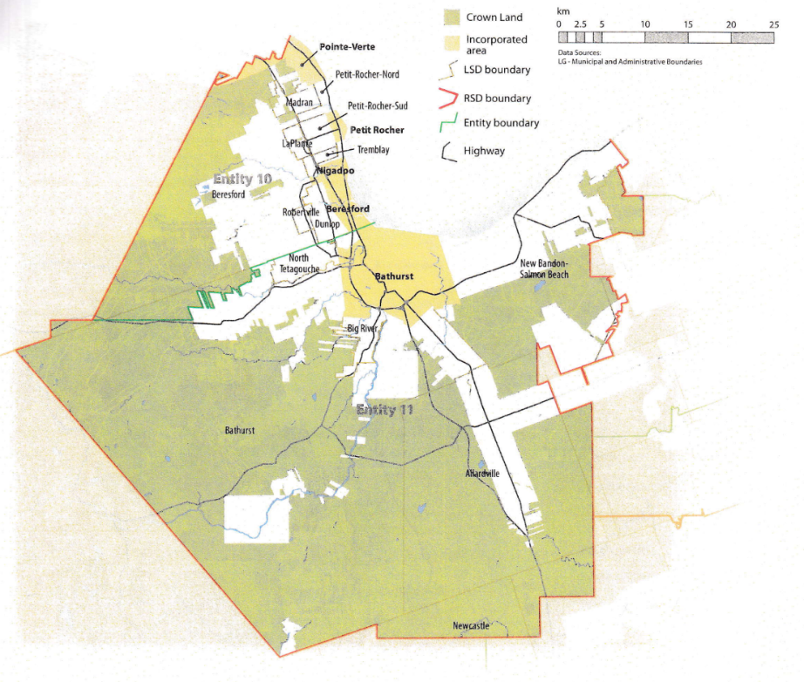
Many of these services, however, would be better served being provided at the regional rather than local level. Rather than leaving some services in the care of the province, the new framework provides Regional Service Districts within which municipalities can collaborate on such basic services as policing, waste management, and land-use planning. Collaboration on these issues will further reduce cost for services, allowing property tax rates to remain at a reasonable rate.
Entity 11 would therefore share a number of responsibilities such as solid waste disposal, economic development, and policing with its neighbour Entity 11 through Regional Service District 3. As with each municipal entity, RSDs could conceivably be named, but this would be left to each community to determine for itself. Both entities would be equal partners in the provision of regional services, with each having a comparable demographic and tax base. While this region is far too large to be incorporated into a single municipality, the populations nonetheless have a great deal of shared experiences and challenges. The RSD can therefore help address common economic and service related challenges without compromising the self-governance of any constituent entity.
Overall, however, the new framework would clarify the distinction between municipal and provincial responsibilities. While today the service provision of roads, animal control, and policing is dependent on whether or not you live in an incorporated or unincorporated local governance entity, in the new framework, all of these services will be provided by the municipal government – either directly or in coalition with its neighbouring municipalities. When the residents know exactly who is accountable for what, services will improve.
Summation
Overall, Entity 11 would allow all residents of the greater Bathurst area to enjoy a comparable level of service in correlation with their level of taxation, to feel represented at a local level and have a real say in how their property tax dollars are being spent, and create a municipal entity that is sustainable enough to navigate the demographic and economic challenges of the 21st century.

Finn, 181.
Finn, 90.

