An Image of the Future – Entity 14 and Regional Service District 4
To illustrate the benefits of this new framework, take the example of Entity 14. For the duration of this discussion the municipality shall be referred to as Entity 14, as while the municipality could conceivably adopt Miscou, Lamèque. or any other name, the naming of the 53 municipal entities remains a task for the citizens of each proposed entity. Leaving the name of each entity undetermined is an important measure for the development of sustainable new municipal identities to compliment those of the existing towns, villages, and LSDs.
Geographic Boundaries
Entity 14 would be comprised of the Town of Lamèque, the Village of Sainte-Marie-Saint-Raphaël, and the Cap-Bateau, Chaisson-Savoy, Coteau Road, Haut-Lamèque, Miscou Island, Petit- Lamèque, Pigeon Hill, Pointe Alexandre, Pointe Canot, Shippagan, and Ste. Cecile LSDs. The proposed entity would encompass the northernmost islands of the Acadian peninsula.
Demographic Base
The total population of the municipality would be approximately 6400 people. Since 2011, this number has declined by about 6%. In accordance with the Official Languages Act, Entity 14 would not be required to operate bilingually because less than 20% of the total population are Anglophones.
Voter Turnout by Existing Municipality
Municipality | Voter Participation 2012¹ | Voter Participation 2016
Lamèque | 63.3% | 63.4%
Sainte-Marie-Saint-Raphaël | 68.5% | 45.4%
1. Elections NB
As it stands today, the democratic health of the proposed entity is deteriorating. 66% of the proposed entity’s population live in unincorporated areas and are accordingly without representative local government. In addition to the lack of democratic institutions, the lack of incorporated municipal entities means that there is no land use planning to coordinate economic development. Amalgamation into Entity 14 would therefore benefit the residents of the effected LSDs by enabling them to use the resources they possess and control this development through local representative institutions.
In addition, amalgamation would benefit the proposed
Status of By-Elections for Mayors and/or Councillors
Municipality | 2018 By-Election(s) |  | 2019 By-Election(s)
 | Mayor | Councillor | Mayor | Councillor
Lamèque | N/A | N/A | N/A | N/A
Sainte-Marie-Saint-Raphaël | N/A | Contested | Acclaimed | Contested
1. Elections NB
entity’s existing municipality’s democratic institutions. While the voter participation rate in Lamèque is high, Sainte-Marie-Saint-Raphaël has seen its voter turnout plummet by more than 20 points between the 2012 and 2016 quadrennial municipal elections. Unlike many of the communities in neighbouring Entity 13, Sainte-Marie-Saint-Raphaël has had enough interested candidates to hold contested by-elections, the frequency of these byelections in the years since the last quadrennial election is a cause of concern.
By amalgamating into the proposed Entity 14, the size of the electorate and candidate pool would increase significantly. An example of such a strategy succeeding can be observed in the Village of Eel River Crossing. In 2014, a number of contiguous LSDs voted to join the nearby village, resulting in a 2015 election which was highly contested. Eel River Crossing’s first election saw 8 candidates compete for 4 at-large councillor positions. Of these 8 candidates, 4 were from previously unincorporated areas. Because the population of these LSDs represent just less than half of the proposed entity’s total population, enabling their participation as both voters and candidates will give Entity 14 a better chance at developing healthy and sustainable democratic institutions.
Financial Base
In 2017, the residents of the communities of Cap-Bateau, Coteau Road, Haut-Lamèque, Miscou Island, Ste. Cecile, Petite-Lamèque, Pigeon Hill, Pointe-Alexandre, Pointe-Canot, and the parish of Shippegan defeated a plebiscite determining the interest in amalgamating into a Rural Community. While the proposed Entity 14’s boundaries are more or less equivalent to those proposed in this plebiscite, the new framework has more to offer in terms of financial capacity than a Rural Community could.
Entity 14 will also have a financial base capable of service provision beyond a simple aggregation of the assessed value of each constituent municipality and LSD. Under the new framework, municipal revenues will come from a combination of equalization payments from the provincial government, municipal property taxes, and other user fees related to services like water and wastewater usage.
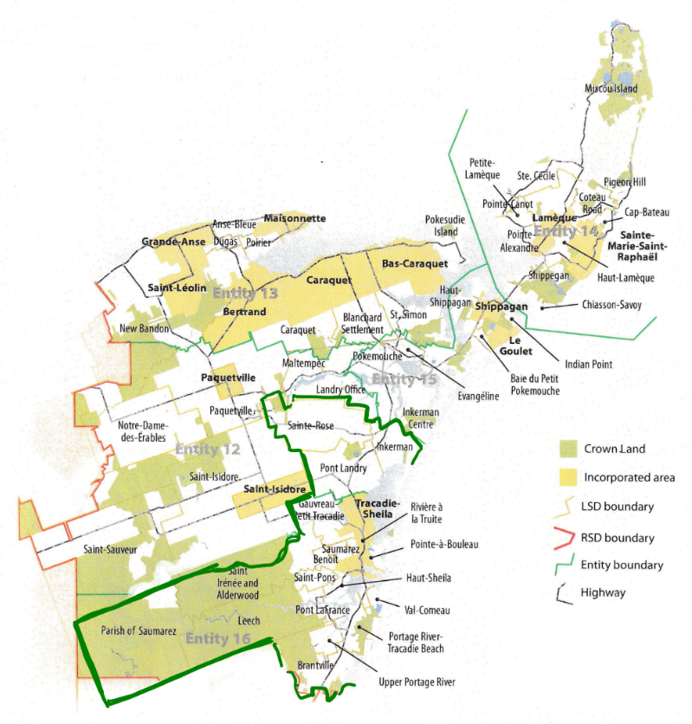
Because its population is below 10000, Entity 14 would qualify as a ‘Group A’ municipality. As Entity 14’s assessment base per capita would be lesser than the group average, it would be entitled to an annual equalization grant of $1,517,53 to ensure equal opportunity among the 53 municipal entities. With the tax room transfer from the provincial government to municipal governments included in the proposed new framework, Entity 14’s assessment base of $302,458,400 would also be able to yield more revenue than it could under the current local governance regime. Equal Opportunity among municipalities remains a priority in the new framework, but the primary guarantor of said equality is now tax warrants rather than equalization payments.
Of course, this tax room transfer does not necessitate that property tax rates will increase by $1.50 per $100 of valuation across Entity 14, nor does it indicate that the entire municipality will operate with one uniform property tax rate. Because Entity 14 would be composed of suburban and rural populations and since the level of local services may vary considerably within the same municipality, existing provisions regarding differentiated tax rates within the same municipality would need to be used. Residents within each municipality should be taxed for the level of services they receive.
As has been seen in many municipalities around the province, municipalities can adopt differing tax rates for different areas under their jurisdiction. For example, while Eel River Crossing’s property tax rate in 2011 was $1.32 per $100, each former LSD had different, lower property tax rates appropriate to their circumstances. Similar situations can be found across the province, with some cities even imposing different tax rates for those inside and outside the urban center. Entity 14 could easily implement a two tiered property tax regime similar to Fredericton and Dieppe where those inside the urban area and those outside are charged substantially different rates.
Overall, then, Entity 14 would have a financial base appropriate to its size and population. With such a financial base, the municipal entity could be as ambitious or cautious in its service provision as its residents please.
Division of Municipal and Provincial Responsibilities
In addition to policing, emergency measures planning, fire prevention and suppression, roads, and garbage disposal, a municipality may choose to enlarge its role and provide a great number of other services. Many municipalities also take responsibility for local arts and culture, parks and recreation, public transportation, and more. Whether or not this sort of expansion is done is entirely up to the residents of Entity 14, and the tax rates of the entity would reflect this level of service.
Many of these services, however, would be better served being provided at the regional rather than local level. Rather than leaving some services in the care of the province, the new framework provides Regional Service Districts within which municipalities can collaborate on such basic services as policing, waste management, economic development, and land-use planning. Collaboration on these issues will further reduce cost for services, allowing property tax rates to remain at a reasonable rate.
Entity 14 would belong to RSD 4 along with its neighbours Entities 12, 13, 15, and 16, covering portions of both Glouchester and Northumberland counties. As with each municipal entity, RSDs could conceivably be named, but this would be left to each to determine for itself. All 5 entities would be partners in the provision of regional services, with each contributing in accordance with their respective demographic and tax bases.
While this region is far too large to be incorporated into a single municipality, the populations nonetheless have a great deal of shared experiences and challenges. 50% of commuters travel out of their own community every day, but remain within their own county, indicating a high level of economic interconnectivity in RSD 4.
By better enabling municipalities to provide the services their citizens require through cooperation in service provision, the new framework would therefor clarify the distinction between municipal and provincial responsibilities. While today the service provision of roads, animal control, and policing is dependent on whether or not you live in an incorporated or unincorporated local governance entity, in the new framework, all of these services will be provided by the municipal government. When the residents know exactly who is accountable for what, services will improve.
Summation
Overall, Entity 14 would allow all residents to enjoy a comparable level of service in correlation with their level of taxation, to feel represented at a local level and have a real say in how their property tax dollars are being spent, and create a municipal entity that is sustainable enough to navigate the demographic and economic challenges of the 21st century.

Finn, 111.
Finn, 90.

