An Image of the Future – Entity 16 and Regional Service District 4
To illustrate the benefits of this new framework, take the example of Tracadie. While the naming of the 53 municipal entities remains a task for the citizens of each proposed entity as an important measure for the development of sustainable new municipal identities, the proposed Entity 16 is already entirely encompassed by the Regional Municipality of Tracadie. Like the rest of the entities proposed in this new framework, Tracadie had to engage in a process of self-reflection about its new identity before deciding on a name. Whereas Grand Tracadie-Sheila was the name originally given to the Regional Municipality while it decided on a permanent name, comparable names have not been given to the other 52 entities who have not already amalgamated of their own accord to encourage a similar process of identity formation.
Geographic Boundaries
In contrast to the boundaries of Entity 16 proposed in 2008, Tracadie includes the former LSDs of Sainte Rose, Pont Landry, and Inkerman. Because the amalgamation of these communities occurred without direct reference to the proposed framework described in this report, many of the boundaries of Entity 16 which followed Crown Lands now follow existing parish lines which makes its borders atypical among the 53 proposed entities. No changes to these borders are recommended though as Tracadie
Demographic Base
Tracadie’s population has been stable since 2011 with approximately 16000 people. In accordance with the Official Languages Act, Entity 16 would not be required to operate bilingually because less than 20% of the total population are Anglophones.
Since of amalgamating into the Regional Municipality of Tracadie, voter turnout has increased 17%, though even as the former town of Tracadie-Sheila voter participation was above the provincial average. Nonetheless, as with other communities in the north of the province, Tracadie has seen multiple by-elections in the years since the 2016 quadrennial elections. While frequent by-elections can indicate a degradation in the potential candidate pool, the significant increase in councilor resignations as of 2016 may be attributable to the leadership style of new
Voter Turnout by Existing Municipality
Municipality | Voter Participation 2012¹ | Voter Participation 2016
Tracadie | 51.1% | 59.9%
1. Elections NB
Mayor Denis Losier. Of the three by-elections held in 2018, two councilors were selected in contested races and one was elected by acclamation. Considering the challenges for a municipality when a majority of its veteran councilors resign, the quick replenishment of councilors indicates the benefit of incorporating the populations of nearby LSDs for the sustainability of candidate pools. While the immediate future of Tracadie’s municipal politics may be uncertain, the consolidation of the Regional Municipality’s populations will prove to be beneficial to the health of democratic institutions in the long term.
Financial Base
Entity 16 will also have a financial base capable of service provision beyond a simple aggregation of the assessed value of each constituent municipality and LSD. As Tracadie has already amalgamated into a Regional Municipality, the biggest change the new framework would bring would be in terms of funding. Under the new framework, municipal revenues will come from a combination of equalization payments from the provincial government, municipal property taxes, and other user fees related to services like water and wastewater usage.
Because its population is above 10000, Entity 16 would qualify as a ‘Group B’ municipality. As Entity 16’s assessment base per capita would be lesser than the group average, it would be entitled to an annual equalization grant of $2,758,617 to ensure equal opportunity among the 53 municipal entities. With the tax room transfer from the provincial government to municipal governments included in the proposed new framework, Entity 16’s assessment base of $1,015,752,100 would also be able to yield more revenue than it could under the current local governance regime. Equal Opportunity among municipalities remains a priority in the new framework, but the primary guarantor of said equality is now tax warrants rather than equalization payments.
Of course, this tax room transfer does not necessitate that property tax rates will increase by $1.50 per $100 of valuation across Entity 16, nor does it indicate that the entire municipality will operate with one uniform property tax rate. Because Entity 16 would be composed of suburban and rural populations and since the level of local services may vary considerably within the same municipality, existing provisions regarding differentiated tax rates within the same municipality would need to be used. Residents within each municipality should be taxed for the level of services they receive.
As has been seen in many municipalities around the province, municipalities can adopt differing tax rates for different areas under their jurisdiction. For example, while Eel River Crossing’s property tax rate in 2011 was $1.32 per $100, each former LSD had different, lower property tax rates appropriate to their circumstances. Similar situations can be found across the province, with some cities even imposing different tax rates for those inside and outside the urban center. Entity 16 could easily implement a two tiered property tax regime similar to Fredericton and Dieppe where those inside the urban area and those outside are charged substantially different rates.
Overall, then, Entity 16 would have a financial base appropriate to its size and population. With such a financial base, the municipal entity could be as ambitious or cautious in its service provision as its residents please.
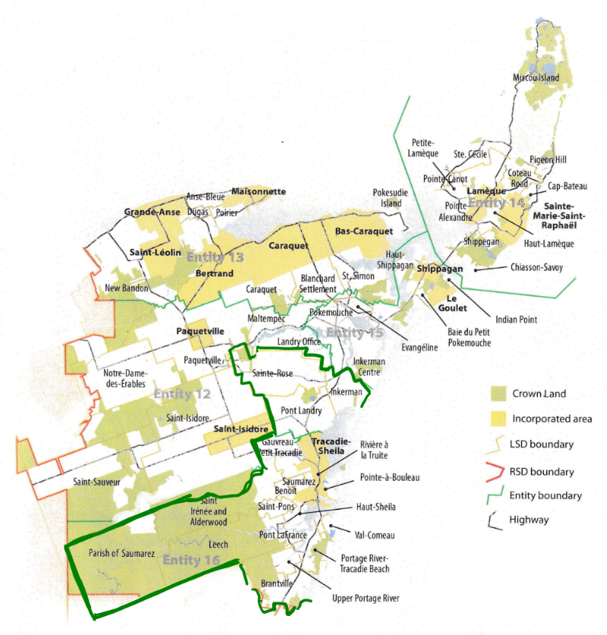
Division of Municipal and Provincial Responsibilities
In addition to policing, emergency measures planning, fire prevention and suppression, roads, and garbage disposal, a municipality may choose to enlarge its role and provide a great number of other services. Many municipalities also take responsibility for local arts and culture, parks and recreation, public transportation, and more. Whether or not this sort of expansion is done is entirely up to the residents of Entity 16, and the tax rates of the entity would reflect this level of service.
Many of these services, however, would be better served being provided at the regional rather than local level. Rather than leaving some services in the care of the province, the new framework provides Regional Service Districts within which municipalities can collaborate on such basic services as policing, waste management, economic development, and land-use planning. Collaboration on these issues will further reduce cost for services, allowing property tax rates to remain at a reasonable rate.
Entity 16 would belong to RSD 4 along with its neighbours Entities 12, 13, 15, and 16, covering portions of both Glouchester and Northumberland counties. As with each municipal entity, RSDs could conceivably be named, but this would be left to each to determine for itself. All 5 entities would be partners in the provision of regional services, with each contributing in accordance with their respective demographic and tax bases.
While this region is far too large to be incorporated into a single municipality, the populations nonetheless have a great deal of shared experiences and challenges. 50% of commuters travel out of their own community every day, but remain within their own county, indicating a high level of economic interconnectivity in RSD 4.
By better enabling municipalities to provide the services their citizens require through cooperation in service provision, the new framework would therefor clarify the distinction between municipal and provincial responsibilities. While today the service provision of roads, animal control, and policing is dependent on whether or not you live in an incorporated or unincorporated local governance entity, in the new framework, all of these services will be provided by the municipal government. When the residents know exactly who is accountable for what, services will improve.
Summation
Overall, Entity 16 would allow all residents of the province’s northern panhandle to enjoy a comparable level of service in correlation with their level of taxation, to feel represented at a local level and have a real say in how their property tax dollars are being spent, and create a municipal entity that is sustainable enough to navigate the demographic and economic challenges of the 21st century.

Finn, 111.
https://www.cbc.ca/news/canada/new-brunswick/tracadie-council-resignations-raymonde-robichaud-1.4856042
Finn, 90.

