An Image of the Future – Entity 19 and Regional Service District 5
To illustrate the benefits of this new framework, take the example of Entity 19. For the duration of this discussion the municipality shall be referred to as Entity 19, as while the municipality could conceivably adopt Upper Miramichi, Doaktown, or any other name, the naming of the 53 municipal entities remains a task for the citizens of each proposed entity. Leaving the name of each entity undetermined is an important measure for the development of sustainable new municipal identities to compliment those of the existing towns, villages, and LSDs.
Geographic Boundaries
Entity 19 would be comprised of the Rural Community of Upper Miramichi, the Villages of Doaktown and Stanley, and the Blissfield and Stanley LSDs. The entity’s Crown Lands would be concentrated in the Blissfield LSD.
Demographic Base
The total population of the municipality would be approximately 4700 people, down from nearly 5000 in 2011. In accordance with the Official Languages Act, Entity 19 would not be required to operate bilingually because less than 20% of the residents are Anglophones.
Voter Turnout by Existing Municipality
Municipality | Voter Participation 2012¹ | Voter Participation 2016
Upper Miramichi | 57.6% | 52.1%
Stanley | acclaimed | acclaimed
Doaktown | 73.6% | 73.4%
1. Elections NB
The proposed entity would function as a broader implementation of the principles which informed the creation of the Upper Miramichi Rural Community. As it stands today, the democratic health of the proposed entity is deteriorating. 28% of the proposed entity’s population live in unincorporated areas and are accordingly without representative local government. In addition to the lack of democratic institutions, the lack of incorporated municipal entities means that there is no land use planning to coordinate economic development. The incorporation of the current LSDs would extend self-government and representative democratic institutions to the remaining 30% of the proposed Entity 19’s population who are denied these basic freedoms.
The expansion of the electorate would also improve the sustainability of the municipality’s potential candidate pool. While Upper Miramichi and Doaktown both report higher than average voter turnout rates in the last two quadrennial elections, Stanley has been unable to attract enough interest to hold contested elections in either 2012 or 2016. The incorporation of Upper Miramichi in 2008 already serves as a precedent for the potential interest which residents of unincorporated areas may have in exercising their democratic rights, but the situation in Stanley also highlights the potential benefits to the area’s democratic health as a whole.
Financial Base
Entity 19 will also have a financial base capable of service provision beyond a simple aggregation of the assessed value of each constituent municipality and LSD. Under the new framework, municipal revenues will come from a combination of equalization payments from the provincial government, municipal property taxes, and other user fees related to services like water and wastewater usage.
Because its population is below 10000, Entity 19 would qualify as a ‘Group A’ municipality. As Entity 19’s assessment base per capita would be lesser than the group average, it would be entitled to an annual equalization grant of $648,770 to ensure equal opportunity among the 53 municipal entities. With the tax room transfer from the provincial government to municipal governments included in the proposed new framework, Entity 19’s assessment base of $261,114,400 would also be able to yield more revenue than it could under the current local governance regime. Equal Opportunity among municipalities remains a priority in the new framework, but the primary guarantor of said equality is now tax warrants rather than equalization payments.
Beyond this unconditional grant, however, Entity 19 will have additional revenue raising power. Of course, this tax room transfer does not necessitate that property tax rates will increase by $1.50 per $100 of valuation across Entity 19, nor does it indicate that the entire municipality will operate with one uniform property tax rate. Because Entity 19 would be composed of suburban and rural populations and since the level of local services may vary considerably within the same municipality, existing provisions regarding differentiated tax rates within the same municipality would need to be used. Residents within each municipality should be taxed for the level of services they receive.
As has been seen in many municipalities around the province, municipalities can adopt differing tax rates for different areas under their jurisdiction. For example, while Eel River Crossing’s property tax rate in 2011 was $1.32 per $100, each former LSD had different, lower property tax rates appropriate to their circumstances. Similar situations can be found across the province, with some cities even imposing different tax rates for those inside and outside the urban center. Entity 19 could easily implement a two tiered property tax regime similar to Fredericton and Dieppe where those inside the urban area and those outside are charged substantially different rates.
Overall, then, Entity 19 would have a financial base appropriate to its size and population. With such a financial base, the municipal entity could be as ambitious or cautious in its service provision as its residents please.
Division of Municipal and Provincial Responsibilities
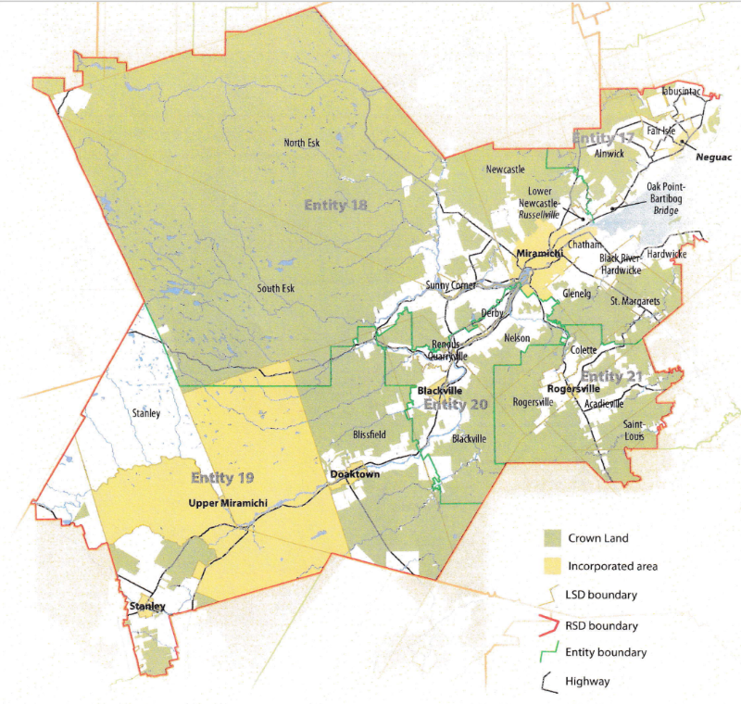
In addition to policing, emergency measures planning, fire prevention and suppression, roads, and garbage disposal, a municipality may choose to enlarge its role and provide a great number of other services. Many municipalities also take responsibility for local arts and culture, parks and recreation, public transportation, and more. Whether or not this sort of expansion is done is entirely up to the residents of Entity 19, and the tax rates of the entity would reflect this level of service.
Many of these services, however, would be better served being provided at the regional rather than local level. Rather than leaving some services in the care of the province, the new framework provides Regional Service Districts within which municipalities can collaborate on such basic services as policing, waste management, economic development, and land-use planning. Collaboration on these issues will further reduce cost for services, allowing property tax rates to remain at a reasonable rate.
Entity 19 would belong to RSD 5 along with its neighbours Entities 17, 18, 20, and 21 covering portions of Northumberland, Kent and York counties. As with each municipal entity, RSDs could conceivably be named, but this would be left to each to determine for itself. All 5 entities would be partners in the provision of regional services, with each contributing in accordance with their respective demographic and tax bases.
While this region is far too large to be incorporated into a single municipality, the populations nonetheless have a great deal of shared experiences and challenges. Overall, 49% of RSD 5’s residents live and work within their own municipal entity. A further 40% work in a different community within their own county, but these numbers change dramatically depending on which municipal entity is examined. Entities 19 and 21 contain existing municipalities in counties other than Northumberland. Accordingly, their reported inter-county commuter rates are far higher than their neighbours’. Approximately 25% of both entities’ commuters need to lerave their county of residence in order to find work, indicating that despite crossing traditional county lines, the borders of RSD 5 better reflect the needs of its residents.
By better enabling municipalities to provide the services their citizens require through cooperation in service provision, the new framework would therefor clarify the distinction between municipal and provincial responsibilities. While today the service provision of roads, animal control, and policing is dependent on whether or not you live in an incorporated or unincorporated local governance entity, in the new framework, all of these services will be provided by the municipal government. When the residents know exactly who is accountable for what, services will improve.
Summation
Overall, Entity 19 would allow all residents to enjoy a comparable level of service in correlation with their level of taxation, to feel represented at a local level and have a real say in how their property tax dollars are being spent, and create a municipal entity that is sustainable enough to navigate the demographic and economic challenges of the 21st century.

Finn, 111.
Finn, 90.

