An Image of the Future – Entity 20 and Regional Service District 5
To illustrate the benefits of this new framework, take the example of Entity 20. For the duration of this discussion the municipality shall be referred to as Entity 20, as while the municipality could conceivably adopt Blackville or any other name, the naming of the 53 municipal entities remains a task for the citizens of each proposed entity. Leaving the name of each entity undetermined is an important measure for the development of sustainable new municipal identities to compliment those of the existing towns, villages, and LSDs.
Geographic Boundaries
Entity 20 would be comprised of the Village of Blackville and the Blackville, Derby, Nelson, Renous-Quarryville LSDs. Other than those areas in the immediate periphery of the village and LSDs, Entity 20 consists primarily of Crown Lands.
Demographic Base
The total population of the municipality would be approximately 4900 people, down from nearly 5100 in 2011. In accordance with the Official Languages Act, Entity 20 would not be required to operate bilingually because less than 20% of the residents are Anglophones.
Voter Turnout by Existing Municipality
Municipality | Voter Participation 2012¹ | Voter Participation 2016
Blackville | 73.65% | 76.15%
1. Elections NB
As it stands today, nearly 80% of the proposed entity’s population live in unincorporated areas and accordingly do not have access to local representative institutions. While Blackville has a small population in comparison with the combined LSDs which surround it, its democratic institutions are in good health. Blackville has high voter turnout and has seen increases in that turnout rate over the last two quadrennial elections. If the surrounding LSDs were incorporated into the proposed Entity 20, the good health of Blackville’s democratic institutions would do well to encourage voter participation in the rest of Entity 20. In addition, while there do not appear to be problems associated with Blackville’s potential candidate pool as of yet, increasing the municipality’s population would shore up that candidate pool for the future.
Financial Base
Entity 20 will also have a financial base capable of service provision beyond a simple aggregation of the assessed value of each constituent municipality and LSD. Under the new framework, municipal revenues will come from a combination of equalization payments from the provincial government, municipal property taxes, and other user fees related to services like water and wastewater usage.
Because its population is below 10000, Entity 20 would qualify as a ‘Group A’ municipality. As Entity 20’s assessment base per capita would be lesser than the group average, it would be entitled to an annual equalization grant of $504,382 to ensure equal opportunity among the 53 municipal entities. With the tax room transfer from the provincial government to municipal governments included in the proposed new framework, Entity 20’s assessment base of $300,939,300 would also be able to yield more revenue than it could under the current local governance regime. Equal Opportunity among municipalities remains a priority in the new framework, but the primary guarantor of said equality is now tax warrants rather than equalization payments.
Of course, this tax room transfer does not necessitate that property tax rates will increase by $1.50 per $100 of valuation across Entity 20, nor does it indicate that the entire municipality will operate with one uniform property tax rate. Because Entity 20 would be composed of suburban and rural populations and since the level of local services may vary considerably within the same municipality, existing provisions regarding differentiated tax rates within the same municipality would need to be used. Residents within each municipality should be taxed for the level of services they receive.
As has been seen in many municipalities around the province, municipalities can adopt differing tax rates for different areas under their jurisdiction. For example, while Eel River Crossing’s property tax rate in 2011 was $1.32 per $100, each former LSD had different, lower property tax rates appropriate to their circumstances. Similar situations can be found across the province, with some cities even imposing different tax rates for those inside and outside the urban center. Entity 20 could easily implement a two tiered property tax regime similar to Fredericton and Dieppe where those inside the urban area and those outside are charged substantially different rates.
Overall, then, Entity 20 would have a financial base appropriate to its size and population. With such a financial base, the municipal entity could be as ambitious or cautious in its service provision as its residents please.
Division of Municipal and Provincial Responsibilities
In addition to policing, emergency measures planning, fire prevention and suppression, roads, and garbage disposal, a municipality may choose to enlarge its role and provide a great number of other services. Many municipalities also take responsibility for local arts and culture, parks and recreation, public transportation, and more. Whether or not this sort of expansion is done is entirely up to the residents of Entity 20, and the tax rates of the entity would reflect this level of service.
Many of these services, however, would be better served being provided at the regional rather than local level. Rather than leaving some services in the care of the province, the new framework provides Regional Service Districts within which municipalities can collaborate on such basic services as policing, waste management, economic development, and land-use planning. Collaboration on these issues will further reduce cost for services, allowing property tax rates to remain at a reasonable rate.
Entity 20 would belong to RSD 5 along with its neighbours Entities 17, 18, 19, and 21 covering portions of Northumberland, Kent and York counties. As with each municipal entity, RSDs could conceivably be named, but this would be left to each to determine for itself. All 5 entities would be partners in the provision of regional services, with each contributing in accordance with their respective demographic and tax bases.
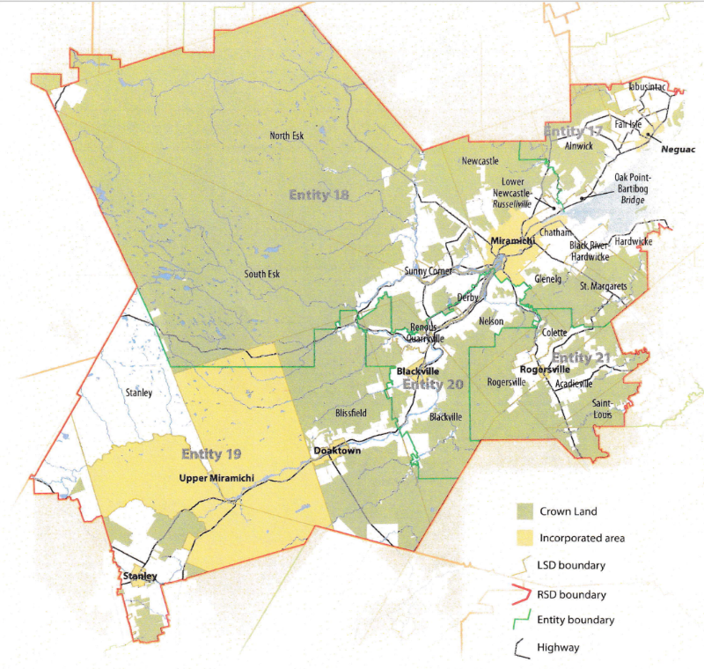
While this region is far too large to be incorporated into a single municipality, the populations nonetheless have a great deal of shared experiences and challenges. Overall, 49% of RSD 5’s residents live and work within their own municipal entity. A further 40% work in a different community within their own county, but these numbers change dramatically depending on which municipal entity is examined. Entities 19 and 21 contain existing municipalities in counties other than Northumberland. Accordingly, their reported inter-county commuter rates are far higher than their neighbours’. Approximately 25% of both entities’ commuters need to lerave their county of residence in order to find work, indicating that despite crossing traditional county lines, the borders of RSD 5 better reflect the needs of its residents. In the case of Entity 20, over 70% of commuters travel outside of their communities within Northumberland county, emphasisxing the important role which the Miramichi economic hub plays for the entire region.
By better enabling municipalities to provide the services their citizens require through cooperation in service provision, the new framework would therefor clarify the distinction between municipal and provincial responsibilities. While today the service provision of roads, animal control, and policing is dependent on whether or not you live in an incorporated or unincorporated local governance entity, in the new framework, all of these services will be provided by the municipal government. When the residents know exactly who is accountable for what, services will improve.
Summation
Overall, Entity 20 would allow all residents to enjoy a comparable level of service in correlation with their level of taxation, to feel represented at a local level and have a real say in how their property tax dollars are being spent, and create a municipal entity that is sustainable enough to navigate the demographic and economic challenges of the 21st century.

Finn, 111.
Finn, 90.

