An Image of the Future – Entity 24 and Regional Service District 6
To illustrate the benefits of this new framework, take the example of Entity 24. For the duration of this discussion the municipality shall be referred to as Entity 24, as while the municipality could conceivably adopt Bouctouche or any other name, the naming of the 53 municipal entities remains a task for the citizens of each proposed entity. Leaving the name of each entity undetermined is an important measure for the development of sustainable new municipal identities to compliment those of the existing towns, villages, and LSDs.
Geographic Boundaries
Entity 24 would be comprised of the Town of Bouctouche and the Saint Mary, Wellington, and Saint-Anne-de-Kent LSDs. The proposed entity would lie on the coast of the Northumberland Straight, with most of the entity’s Crown Lands concentrated in the Saint Mary LSD.
Demographic Base
The total population of the municipality would be approximately 7200 people, down from 7300 in 2011. In accordance with the Official Languages Act, Entity 24 would not be required to operate bilingually because less than 20% of the population are Anglophones.
As it stands today, 67% of the proposed entity’s population live in unincorporated areas and are accordingly without representative local government. In addition to the lack of democratic institutions, the lack of incorporated municipal entities means that there is almost no land use planning in the area of proposed Entity 24. Because there are so few Crown Lands in the proposed entity, Entity 24 has the potential to be developed, but doing so requires proper land use planning. Amalgamation into Entity 24 would therefore benefit the residents of the affected LSDs by enabling them to use the resources they possess and control this development through local representative institutions.
Voter Turnout by Existing Municipality
Municipality | Voter Participation 2012¹ | Voter Participation 2016
Bouctouche | 58.2% | 56.4%
1. Elections NB
While Bouctouche has a small population in comparison with the combined LSDs which surround it, its democratic institutions are in good health. Bouctouche has high voter turnout and has seen significant increases in that turnout rate over the last two quadrennial elections. If the surrounding LSDs were incorporated into the proposed Entity 24, the good health of Bouctouche’s democratic institutions would do well to encourage voter participation in the rest of Entity 24. In addition, while there do not appear to be problems associated with Bouctouche’s potential candidate pool as of yet, increasing the municipality’s population would shore up that candidate pool for the future.
Financial Base
Entity 24 will also have a financial base capable of service provision beyond a simple aggregation of the assessed value of each constituent municipality and LSD. Under the new framework, municipal revenues will come from a combination of equalization payments from the provincial government, municipal property taxes, and other user fees related to services like water and wastewater usage.
Because its population is below 10000, Entity 24 would qualify as a ‘Group A’ municipality. As Entity 24’s assessment base per capita would be greater than the group average, it would not be entitled to an annual equalization grant. Rather, equal opportunity among the 53 municipalities would be guaranteed by its expanded tax warrant. With the tax room transfer from the provincial government to municipal governments included in the proposed new framework, Entity 24’s assessment base of $294,840,100 would be able to yield more revenue than it could under the current local governance regime. Equal Opportunity among municipalities remains a priority in the new framework, but the primary guarantor of said equality is now tax warrants rather than equalization payments.
Of course, this tax room transfer does not necessitate that property tax rates will increase by $1.50 per $100 of valuation across Entity 24, nor does it indicate that the entire municipality will operate with one uniform property tax rate. Because Entity 24 would be composed of suburban and rural populations and since the level of local services may vary considerably within the same municipality, existing provisions regarding differentiated tax rates within the same municipality would need to be used. Residents within each municipality should be taxed for the level of services they receive.
As has been seen in many municipalities around the province, municipalities can adopt differing tax rates for different areas under their jurisdiction. For example, while Eel River Crossing’s property tax rate in 2011 was $1.32 per $100, each former LSD had different, lower property tax rates appropriate to their circumstances. Similar situations can be found across the province, with some cities even imposing different tax rates for those inside and outside the urban center. Entity 24 could easily implement a two tiered property tax regime similar to Fredericton and Dieppe where those inside the urban area and those outside are charged substantially different rates.
Overall, then, Entity 24 would have a financial base appropriate to its size and population. With such a financial base, the municipal entity could be as ambitious or cautious in its service provision as its residents please.
Division of Municipal and Provincial Responsibilities
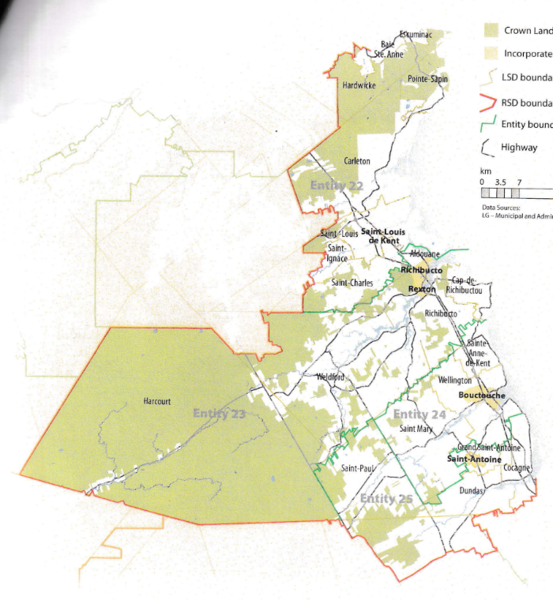
In addition to policing, emergency measures planning, fire prevention and suppression, roads, and garbage disposal, a municipality may choose to enlarge its role and provide a great number of other services. Many municipalities also take responsibility for local arts and culture, parks and recreation, public transportation, and more. Whether or not this sort of expansion is done is entirely up to the residents of Entity 24, and the tax rates of the entity would reflect this level of service.
Many of these services, however, would be better served being provided at the regional rather than local level. Rather than leaving some services in the care of the province, the new framework provides Regional Service Districts within which municipalities can collaborate on such basic services as policing, waste management, economic development, and land-use planning. Collaboration on these issues will further reduce cost for services, allowing property tax rates to remain at a reasonable rate.
Entity 24 would belong to RSD 6 along with its neighbours Entities 22, 23, and 25 covering Kent and portions of Northumberland and Westmorland counties. As with each municipal entity, RSDs could conceivably be named, but this would be left to each to determine for itself. All 4 entities would be partners in the provision of regional services, with each contributing in accordance with their respective demographic and tax bases.
While this region is far too large to be incorporated into a single municipality, the populations nonetheless have a great deal of shared experiences and challenges. The plurality of commuters in RSD 6 travel outside of their own community each day but remain within Kent county. These commuter behaviours are an indication of the pre-existing economic interdependence in the region. However, unlike most other RSDs, RSD 6 has a comparable amount of commuters who leave the RSD and remain within the RSD. Though the narrow plurality is not ideal, the region would still benefit from collective economic planning and service provision. The proportion of commuters who travel within Kent county is far higher in Entity 24 though. Over 50% of commuters travel outside their own community.
By better enabling municipalities to provide the services their citizens require through cooperation in service provision, the new framework would therefor clarify the distinction between municipal and provincial responsibilities. While today the service provision of roads, animal control, and policing is dependent on whether or not you live in an incorporated or unincorporated local governance entity, in the new framework, all of these services will be provided by the municipal government. When the residents know exactly who is accountable for what, services will improve.
Summation
Overall, Entity 24 would allow all residents to enjoy a comparable level of service in correlation with their level of taxation, to feel represented at a local level and have a real say in how their property tax dollars are being spent, and create a municipal entity that is sustainable enough to navigate the demographic and economic challenges of the 21st century.

Finn, 111.
Finn, 90.

