An Image of the Future – Entity 27 and Regional Service District 7
To illustrate the benefits of this new framework, take the example of Entity 27. For the duration of this discussion the municipality shall be referred to as Entity 27, as while the municipality could conceivably adopt the name Moncton, the naming of the 53 municipal entities remains a task for the citizens of each proposed entity. Leaving the name of each entity undetermined is an important measure for the development of sustainable new municipal identities to compliment those of the existing towns, villages, and LSDs.
Geographic Boundaries
Entity 27 would be comprised of the City of Moncton and the continuous portions of the Moncton LSD. The proposed entity would include very little Crown Lands and would be contiguous with the other urban municipal entities containing Riverview and Dieppe. The three municipalities remain separated in the new framework, however, in order to better support the newly incorporated areas which each of the three entities absorb.
Demographic Base
The total population of the municipality would be approximately 80600 people – a 3% increase since 2011. In accordance with the Official Languages Act, Entity 27 would be required to operate bilingually because the Francophone minority is over 30% of the overall population.
As it stands today, 10% of the proposed entity’s population live in unincorporated areas and are accordingly without representative local government. In addition to the lack of democratic institutions, the lack of incorporated municipal entities means that there is no land use planning outside of Moncton proper. Amalgamation into Entity 27 would therefore benefit the residents of the affected LSDs by enabling them to use the resources they possess and control this development through local representative institutions.
Voter Turnout by Existing Municipality
Municipality | Voter Participation 2012¹ | Voter Participation 2016²
Moncton | 33.04% | 35.80%
1. Elections NB
In addition, amalgamation would benefit the proposed entity’s existing municipality’s democratic institutions. Though Moncton is among the most successful municipalities in the province in terms of population and economic growth, its voter turnout rate is consistently below the provincial average. Expanding incorporation and suffrage to contiguous LSDs could improve voter turnout across the municipal entity. Expanding the electorate creates a greater competition of interests, leading to better accountability. However, the more immediate benefit for the proposed municipality is the expansion of the potential candidate pool. An example of such a strategy succeeding can be observed in the Village of Eel River Crossing. In 2014, a number of contiguous LSDs voted to join the nearby village, resulting in a 2015 election which was highly contested. Eel River Crossing’s first election saw 8 candidates compete for 4 at-large councillor positions. Of these 8 candidates, 4 were from previously unincorporated areas. The amalgamation of contiguous local governance entities should therefore be considered by the residents of the entities concerned.
Financial Base
Entity 27 will also have a financial base capable of service provision beyond a simple aggregation of the assessed value of each constituent municipality and LSD. Under the new framework, municipal revenues will come from a combination of equalization payments from the provincial government, municipal property taxes, and other user fees related to services like water and wastewater usage.
Because its population is above 40000, Entity 27 would qualify as a ‘Group C’ municipality. As Entity 27’s assessment base per capita would be greater than the group average, it would not be entitled to an annual equalization grant. Rather, equal opportunity among the 53 municipalities would be guaranteed by its expanded tax warrant. With the tax room transfer from the provincial government to municipal governments included in the proposed new framework, Entity 27’s assessment base of $8,551,993,500 would be able to yield more revenue than it could under the current local governance regime. Equal Opportunity among municipalities remains a priority in the new framework, but the primary guarantor of said equality is now tax warrants rather than equalization payments.
Of course, this tax room transfer does not necessitate that property tax rates will increase by $1.50 per $100 of valuation across Entity 27, nor does it indicate that the entire municipality will operate with one uniform property tax rate. Because Entity 27 would be composed of suburban and rural populations and since the level of local services may vary considerably within the same municipality, existing provisions regarding differentiated tax rates within the same municipality would need to be used. Residents within each municipality should be taxed for the level of services they receive.
As has been seen in many municipalities around the province, municipalities can adopt differing tax rates for different areas under their jurisdiction. For example, while Eel River Crossing’s property tax rate in 2011 was $1.32 per $100, each former LSD had different, lower property tax rates appropriate to their circumstances. Similar situations can be found across the province, with some cities even imposing different tax rates for those inside and outside the urban center. Entity 27 could easily implement a two tiered property tax regime similar to Fredericton and Dieppe where those inside the urban area and those outside are charged substantially different rates.
Overall, then, Entity 27 would have a financial base appropriate to its size and population. With such a financial base, the municipal entity could be as ambitious or cautious in its service provision as its residents please.
Division of Municipal and Provincial Responsibilities
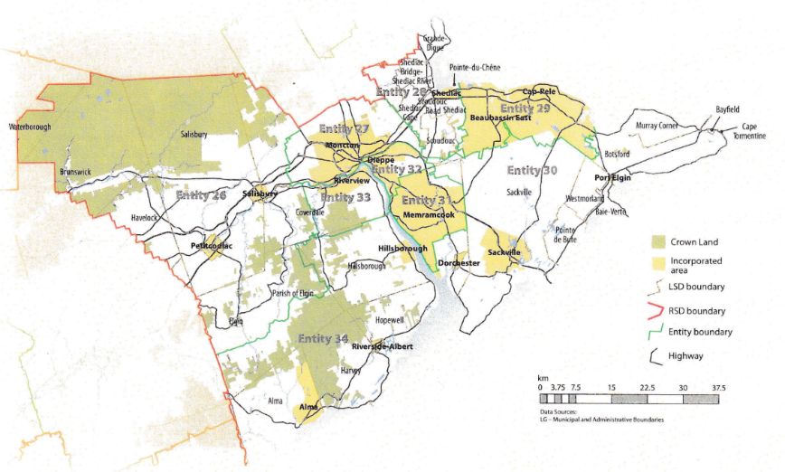
In addition to policing, emergency measures planning, fire prevention and suppression, roads, and garbage disposal, a municipality may choose to enlarge its role and provide a great number of other services. Many municipalities also take responsibility for local arts and culture, parks and recreation, public transportation, and more. Whether or not this sort of expansion is done is entirely up to the residents of Entity 27, and the tax rates of the entity would reflect this level of service.
Many of these services, however, would be better served being provided at the regional rather than local level. Rather than leaving some services in the care of the province, the new framework provides Regional Service Districts within which municipalities can collaborate on such basic services as policing, waste management, economic development, and land-use planning. Collaboration on these issues will further reduce cost for services, allowing property tax rates to remain at a reasonable rate.
Entity 27 would belong to RSD 7 along with its neighbors Entities 26, 28, 29, 30, 31, 32, 33, and 34. As with each municipal entity, RSDs could conceivably be named, but this would be left to each to determine for itself. All entities would be partners in the provision of regional services, with each contributing in accordance with their respective demographic and tax bases.
While this region is far too large to be incorporated into a single municipality, the populations nonetheless have a great deal of shared experiences and challenges. RSD 7 covers both the Westmorland and Albert counties, with Moncton as the economic hub. The distribution of commuters in these counties demonstrate the region’s economic interdependence. Not including Moncton proper as a significant majority of the city’s commuters understandably remain within their own community for work, Westmorland county’s municipalities and LSDs report nearly 70% of commuters as leaving their community of origin for work each day while remaining within Westmorland county. Likewise, nearly 60% of Albert county’s commuters travel outside their county of origin in order to work in the economic hub of Moncton. This economic interdependence represents both a need for collaboration in planning and opportunity for collaboration in service provision.
By better enabling municipalities to provide the services their citizens require through cooperation in service provision, the new framework would therefor clarify the distinction between municipal and provincial responsibilities. While today the service provision of roads, animal control, and policing is dependent on whether or not you live in an incorporated or unincorporated local governance entity, in the new framework, all of these services will be provided by the municipal government. When the residents know exactly who is accountable for what, services will improve.
Summation
Overall, Entity 27 would allow all residents to enjoy a comparable level of service in correlation with their level of taxation, to feel represented at a local level and have a real say in how their property tax dollars are being spent, and create a municipal entity that is sustainable enough to navigate the demographic and economic challenges of the 21st century.

Finn, 111.
Finn, 90.

