An Image of the Future – Entity 29 and Regional Service District 7
To illustrate the benefits of this new framework, take the example of Entity 29. For the duration of this discussion the municipality shall be referred to as Entity 29, as while the municipality could conceivably adopt the name Beaubassin or Cap-Pelé, the naming of the 53 municipal entities remains a task for the citizens of each proposed entity. Leaving the name of each entity undetermined is an important measure for the development of sustainable new municipal identities to compliment those of the existing towns, villages, and LSDs.
Geographic Boundaries
Entity 29 would be comprised of the Village of Cap-Pelé and Rural Community of Beaubassin East. The proposed entity would not include any Crown Lands, and would incorporate any existing LSDs because of Beaubassin’s successful transition into a Rural Community in 1995 and incorporation of Trois-Ruisseaux a decade later.
Voter Turnout by Existing Municipality
Municipality | Voter Participation 2012¹ | Voter Participation 2016²
Cap-Pelé | 59.5% | 64.7%
Beaubassin East | 50.5% | 50.4%
1. Elections NB
Demographic Base
The total population of the municipality would be approximately 8800 people – a 4% increase since 2011. In accordance with the Official Languages Act, Entity 29 would be required to operate bilingually because the Anglophone minority is over 20% of the overall population.
Unlike most other proposed entities, Entity 29 would not include many currently unincorporated areas. However, while both communities included in the proposed entity already enjoy land use planning and local democratic institutions, amalgamation would benefit the health of local democratic institutions. While both Cap-Pelé and Beaubassin East have voter turnout rates higher than the provincial average the frequency and status of by-elections in Beaubassin reveals a looming crisis.

In 2018 and 2019, Beaubassin East saw 3 by-election processes initiated for the role of councillor. The first by-election was unable to be held because of a lack of interested candidates, and the 2019 by-election was decided by acclamation. While already a cause of concern as such results indicate a degradation in the community’s potential candidate pool, frequency of by-elections can also increase voter fatigue.
Status of By-Elections for Mayors and/or Councillors
Municipality | 2018 By-Election(s) |  | 2019 By-Election(s)
 | Mayor | Councillor | Mayor | Councillor
Cap-Pelé | N/A | N/A | N/A | N/A
Beaubassin East | N/A | 1 Unfilled, 1 Contested | N/A | Acclaimed
1. Elections NB
The amalgamation of Cap-Pelé and Beaubassin East would allow both of these concerns to be addressed – provided that ward districts are also redrawn. An example of such a strategy succeeding can be observed in the Village of Eel River Crossing. In 2014, a number of contiguous LSDs voted to join the nearby village, resulting in a 2015 election which was highly contested. Eel River Crossing’s first election saw 8 candidates compete for 4 at-large councillor positions. Of these 8 candidates, 4 were from previously unincorporated areas. The amalgamation of contiguous local governance entities should therefore be considered by the residents of the entities concerned.
Financial Base
Entity 29 will also have a financial base capable of service provision beyond a simple aggregation of the assessed value of each constituent municipality and LSD. Under the new framework, municipal revenues will come from a combination of equalization payments from the provincial government, municipal property taxes, and other user fees related to services like water and wastewater usage.
Because its population is below 10000, Entity 28 would qualify as a ‘Group A’ municipality. As Entity 29’s assessment base per capita would be far greater than the group average, it would not be entitled to an annual equalization grant. Rather, equal opportunity among the 53 municipalities would be guaranteed by its expanded tax warrant. With the tax room transfer from the provincial government to municipal governments included in the proposed new framework, Entity 29’s assessment base of $830,088,400 would be able to yield more revenue than it could under the current local governance regime. Equal Opportunity among municipalities remains a priority in the new framework, but the primary guarantor of said equality is now tax warrants rather than equalization payments.
Of course, this tax room transfer does not necessitate that property tax rates will increase by $1.50 per $100 of valuation across Entity 29, nor does it indicate that the entire municipality will operate with one uniform property tax rate. Because Entity 29 would be composed of suburban and rural populations and since the level of local services may vary considerably within the same municipality, existing provisions regarding differentiated tax rates within the same municipality would need to be used. Residents within each municipality should be taxed for the level of services they receive.
As has been seen in many municipalities around the province, municipalities can adopt differing tax rates for different areas under their jurisdiction. For example, while Eel River Crossing’s property tax rate in 2011 was $1.32 per $100, each former LSD had different, lower property tax rates appropriate to their circumstances. Similar situations can be found across the province, with some cities even imposing different tax rates for those inside and outside the urban center. Entity 29 could easily implement a two tiered property tax regime similar to Fredericton and Dieppe where those inside the urban area and those outside are charged substantially different rates.
Overall, then, Entity 29 would have a financial base appropriate to its size and population. With such a financial base, the municipal entity could be as ambitious or cautious in its service provision as its residents please.
Division of Municipal and Provincial Responsibilities
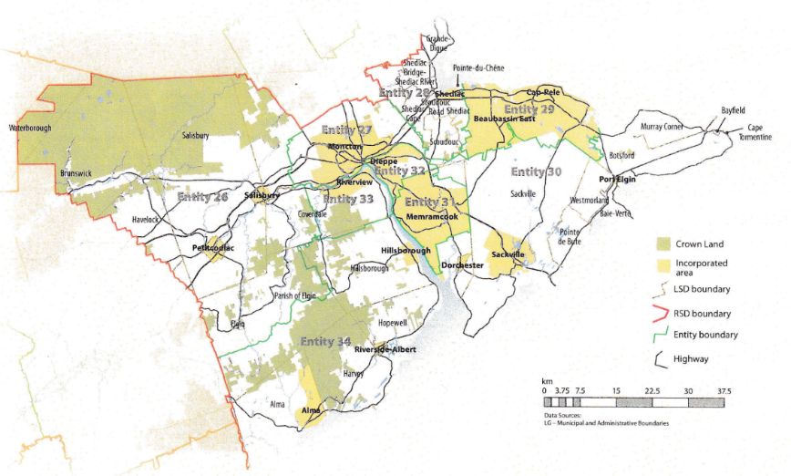
In addition to policing, emergency measures planning, fire prevention and suppression, roads, and garbage disposal, a municipality may choose to enlarge its role and provide a great number of other services. Many municipalities also take responsibility for local arts and culture, parks and recreation, public transportation, and more. Whether or not this sort of expansion is done is entirely up to the residents of Entity 29, and the tax rates of the entity would reflect this level of service.
Many of these services, however, would be better served being provided at the regional rather than local level. Rather than leaving some services in the care of the province, the new framework provides Regional Service Districts within which municipalities can collaborate on such basic services as policing, waste management, economic development, and land-use planning. Collaboration on these issues will further reduce cost for services, allowing property tax rates to remain at a reasonable rate.
Entity 29 would belong to RSD 7 along with its neighbors Entities 26, 27, 28, 30, 31, 32, 33, and 34. As with each municipal entity, RSDs could conceivably be named, but this would be left to each to determine for itself. All entities would be partners in the provision of regional services, with each contributing in accordance with their respective demographic and tax bases.
While this region is far too large to be incorporated into a single municipality, the populations nonetheless have a great deal of shared experiences and challenges. RSD 7 covers both the Westmorland and Albert counties, with Moncton as the economic hub. The distribution of commuters in these counties demonstrate the region’s economic interdependence. Not including Moncton proper as a significant majority of the city’s commuters understandably remain within their own community for work, Westmorland county’s municipalities and LSDs report nearly 70% of commuters as leaving their community of origin for work each day while remaining within Westmorland county. Likewise, nearly 60% of Albert county’s commuters travel outside their county of origin in order to work in the economic hub of Moncton. This economic interdependence represents both a need for collaboration in planning and opportunity for collaboration in service provision.
By better enabling municipalities to provide the services their citizens require through cooperation in service provision, the new framework would therefor clarify the distinction between municipal and provincial responsibilities. While today the service provision of roads, animal control, and policing is dependent on whether or not you live in an incorporated or unincorporated local governance entity, in the new framework, all of these services will be provided by the municipal government. When the residents know exactly who is accountable for what, services will improve.
Summation
Overall, Entity 29 would allow all residents to enjoy a comparable level of service in correlation with their level of taxation, to feel represented at a local level and have a real say in how their property tax dollars are being spent, and create a municipal entity that is sustainable enough to navigate the demographic and economic challenges of the 21st century.

Finn, 111.
Finn, 90.

