An Image of the Future – Entity 3 and Regional Service District 1
To illustrate the benefits of this new framework, take the example of Entity 3. For the duration of this discussion the municipality shall be referred to as Entity 3, as while the municipality could conceivably adopt Saint-Leonard, Saint-Anne, Rivière-Verte, or any other name, the naming of the 53 municipal entities remains a task for the citizens of each proposed entity.0F Leaving the name of each entity undetermined is an important measure for the development of sustainable new municipal identities to compliment those of the existing towns, villages, and LSDs.
Geographic Boundaries
Entity 3 would be comprised of the Town of Saint-Leonard, the Villages of Rivière-Verte, Sainte Anne de Madawaska, and the Rivière-Verte, Sainte-Anne, Notre-Dame-de-Lourdes, and Saint-Leonard LSDs. The municipal entity would stretch across Madawaska county, spanning from the boundaries of Edmundston, to Grand Falls, to Restigouche county. Notably the boundaries of the proposed entity would not correlate with the old parish lines meaning that portions of the Saint-Basile and Drummond LSDs and the corner of Saint-Andre will be included in Entity 3 instead of neighbouring Entity 4. Also, portions of Rivière-Verte, Sainte-Anne, Notre-Dame-de-Lourdes, and Saint-Leonard LSDs will be excluded from Entity 3. Overall, however, the population estimates for following have treated only the LSDs and municipalities with a significant portion of their area included in the proposed Entity 3 as the census data is still divided along existing administrative boundaries.
Demographic Base
The total population of the municipality would be approximately 5900 people. The population has remained rather stable from 2011 to 2016, with only marginal decreases in population. In accordance with the Official Languages Act, Entity 3 would not be required to operate bilingually because over 95% of the residents are Francophones.
As it stands today, the majority of the proposed entity’s population has no representative local government, and accordingly, no local land use planning. Incorporating the entire proposed entity would therefore allow for more cohesive economic and democratic development. Entity 3 has declining democratic health in its incorporated areas and a severe lack of local accountability in its unincorporated areas. While all three existing municipalities have reported voter turnout rates higher than the provincial average in the one of the two last quadrennial elections, Rivière-Verte and Saint-Léonard have also reported elections by acclamation. Furthermore, Sainte Anne de Madawaska’s voter participation dropped 15 points from 2012 to 2016. More concerning, however, is the frequency of by-elections in Rivière-Verte. In 2018 and 2019, the Village was forced to embark on two by-elections as the first was unable to attract any interested candidates. These by-elections are not only an indication of the lack of potential candidates in the community, but can also lead to a more widespread sense of voter apathy.
Voter Turnout by Existing Municipality
Municipality | Voter Participation 2012¹ | Voter Participation 2016
Rivière-Verte | acclaimed | 67.7%
Saint-Léonard | 60.7% | 45.7%
Sainte-Anne-de-Madawaska | 81.7% | acclaimed
1. Elections NB

Status of By-Elections Since 2016
Municipality | 2017 By-Election | 2018 By-Election | 2019 By-Election
Rivière-Verte | N/A | unfilled | acclaimed
Saint-Léonard | N/A | N/A | N/A
Sainte-Anne-de-Madawaska | N/A | N/A | N/A
1. Elections NB
These two problems can be addressed together. By incorporating the entirety of Entity 3, there will be a larger electorate with diverse interests allowing for more competitive elections and importantly, a larger pool of potential candidates. As can be seen in other jurisdictions such as Rural Communities which include formerly unincorporated areas, incorporating an area and allowing it to govern itself responsibly encourages voter participation. The relatively novel Rural Communities, being given a representative local government for the first time since the 1960s, have reported higher than average voter turnout rates with the exceptions of Hanwell and Campobello. The average rate across all 7 communities was 55.42%, but the highest among the class, Kedgwick, had a turnout rate of 73.69%! It could be anticipated, therefore, that the currently unincorporated areas of Entity 30 would bring a good deal of competition to the municipality’s elections, guaranteeing a vibrant democratic community.
As for the more sustainable candidate pool, the Village of Eel River Crossing provides a good example of how expanding incorporated lands can revive a community’s democratic institutions. In 2014, a number of contiguous LSDs voted to join the nearby village, resulting in a 2015 election which was highly contested. Eel River Crossing’s first election saw 8 candidates compete for 4 at-large councillor positions. Of these 8 candidates, 4 were from previously unincorporated areas.
As over half of the proposed Entity 3’s population currently resides in unincorporated areas, it can be anticipated that their inclusion in the new Entity 3 will improve democratic health for all affected communities.
Financial Base
Entity 3 would also have a financial base capable of service provision beyond a simple aggregation of the assessed value of each constituent municipality and LSD. Under the new framework, municipal revenues will come from a combination of equalization payments from the provincial government, municipal property taxes, and other user fees related to services like water and wastewater usage.
Because its population is below 10,000, Entity 3 would qualify as a ‘Group A’ municipality. As Entity 3’s assessment base per capita would be lesser than the group average, the entity would be entitled to an annual equalization grant of $803,006. With the tax room transfer from the provincial government to municipal governments included in the proposed new framework, Entity 3’s assessment base of $328,755,200 will be able to yield more revenue than it could under the current local governance regime. Equal Opportunity among municipalities remains a priority in the new framework, but the primary guarantor of said equality is now tax warrants rather than equalization payments.
Of course, this tax room transfer does not necessitate that property tax rates will increase by $1.50 per $100 of valuation across Entity 3, nor does it indicate that the entire municipality will operate with one uniform property tax rate. Because Entity 3 would be composed of suburban and rural populations and since the level of local services may vary considerably within the same municipality, existing provisions regarding differentiated tax rates within the same municipality would need to be used. Residents within each municipality should be taxed for the level of services they receive.1F
As has been seen in many municipalities around the province, municipalities can adopt differing tax rates for different areas under their jurisdiction. For example, while Eel River Crossing’s property tax rate in 2011 was $1.32 per $100, each former LSD had different, lower property tax rates appropriate to their circumstances. Similar situations can be found across the province, with some cities even imposing different tax rates for those inside and outside the urban center.
Overall, then, Entity 3 would have a financial base appropriate to its size and population. With such a financial base, the municipal entity could be as ambitious or cautious in its service provision as its residents please.
Division of Municipal and Provincial Responsibilities
In addition to policing, emergency measures planning, fire prevention and suppression, roads, and garbage disposal, a municipality may choose to enlarge its role and provide a great number of other services. Many municipalities also take responsibility for local arts and culture, parks and recreation, public transportation, and more. Whether or not this sort of expansion is done is entirely up to the residents of Entity 3, and the tax rates of the entity would reflect this level of service.
Many of these services, however, would be better served being provided at the regional rather than local level. Rather than leaving some services in the care of the province, the new framework provides Regional Service Districts within which municipalities can collaborate on such basic services as policing, waste management, economic development, and land-use planning. Collaboration on these issues will further reduce cost for services, allowing property tax rates to remain at a reasonable rate.
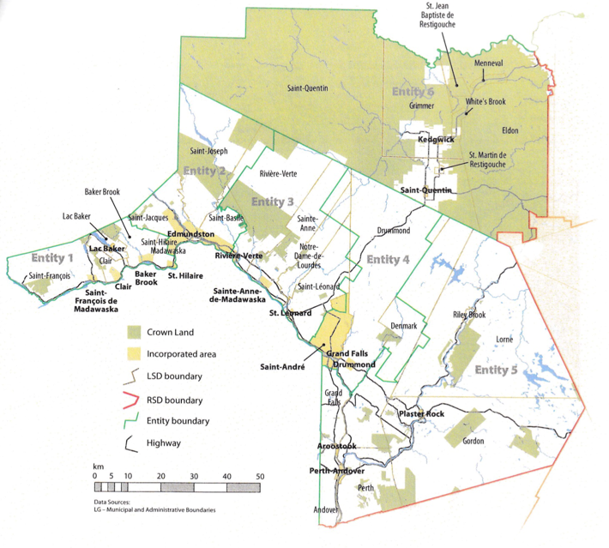
Entity 3 would belong to RSD 1 along with its neighbours Entities 2 to 6, covering Madawaska, Victoria and a portion of Restigouche county. As with each municipal entity, RSDs could conceivably be named, but this would be left to each community to determine for itself. All 6 entities would be partners in the provision of regional services, with each contributing in accordance with their respective demographic and tax bases.
While this region is far too large to be incorporated into a single municipality, the populations nonetheless have a great deal of shared experiences and challenges.
The commuting population of RSD 1 is split between those who commute to work within their own community (46%) those who commute to a different community within the same county (40%), and those commuting to a different county (11%). Entity 3 is of particular interest as it relates to the coherency of the RSD as a whole because of its position at the crossroads of the three effected counties. Entity 3’s commuting population has the smallest proportion of workers who remain within their own community of the six proposed entities of RSD 1. Its labour force is instead concentrated in commuters travelling either within Madawaska county or to Victoria and Restigouche counties. The 63% of Entity 3’s commuters who travel to a different community within Madawaska county indicate a high level of integration with Edmundston, and the 21% who travel out of county demonstrate the interdependence of the three counties labour forces.
The new framework would therefor clarify the distinction between municipal and provincial responsibilities. While today the service provision of roads, animal control, and policing is dependent on whether or not you live in an incorporated or unincorporated local governance entity, in the new framework, all of these services will be provided by the municipal government. When the residents know exactly who is accountable for what, services will improve.
Summation
Overall, Entity 3 would allow its residents to enjoy a comparable level of service in correlation with their level of taxation, to feel represented at a local level and have a real say in how their property tax dollars are being spent, and create a municipal entity that is sustainable enough to navigate the demographic and economic challenges of the 21st century.

Finn, 111.
Finn, 90.

