An Image of the Future – Entity 37 and Regional Service District 9
To illustrate the benefits of this new framework, take the example of Entity 37. For the duration of this discussion the municipality shall be referred to as Entity 37, as while the municipality could conceivably adopt the name Saint Martins or Simonds the naming of the 53 municipal entities remains a task for the citizens of each proposed entity. Leaving the name of each entity undetermined is an important measure for the development of sustainable new municipal identities to compliment those of the existing towns, villages, and LSDs.
Geographic Boundaries
Entity 37 would be comprised of the Village of St Martins and the Saint Martins. Simonds, Fairfield, and Rothesay LSDs. Most of the entity’s Crown Lands would be concentrated in Saint Martins LSD.
Demographic Base
The total population of the municipality would be approximately 5800 people – a population which has remained stable since 2011. In accordance with the Official Languages Act, Entity 37 would not be required to operate bilingually because the Francophone minority is less than 20% of the overall population.
As it stands today, 95% of the proposed entity’s population live in unincorporated areas and are accordingly without representative local government. In addition to the lack of democratic institutions, the lack of incorporated municipal entities means that there is no land use planning to coordinate economic development. Amalgamation into Entity 37 would therefore benefit the residents of the effected LSDs by enabling them to use the resources they possess and control this development through local representative institutions.
In addition, amalgamation would benefit the proposed entity’s existing municipalities’ democratic institutions. St. Martins’ population is decreasing far more quickly than the population of the proposed entity as a whole. With a 12% drop in population from 2011 to 2016, it is unsurprising that the community is also suffering from a shrinking potential candidate pool. While the community was able to hold a contested election in 2016, the 2012 quadrennial election was decided by acclamation. While less quantifiable than voter participation, if a community cannot sustain a pool of interested, qualified, and dedicated potential candidates for public office, the community’s democratic institutions will suffer. A smaller candidate pool also encourages voter apathy as elections will be less competitive regardless of how many voters show up.
Voter Turnout by Existing Municipality
Municipality | Voter Participation 2012¹ | Voter Participation 2016²
St. Martins | acclaimed | 50.43%
1. Elections NB
The solution for the municipalities of proposed Entity 37 is therefore to expand incorporation and suffrage to contiguous LSDs. Expanding the electorate creates a greater competition of interests, leading to better accountability. However, the more immediate benefit for the proposed municipality is the expansion of the potential candidate pool. An example of such a strategy succeeding can be observed in the Village of Eel River Crossing. In 2014, a number of contiguous LSDs voted to join the nearby village, resulting in a 2015 election which was highly contested. Eel River Crossing’s first election saw 8 candidates compete for 4 at-large councillor positions. Of these 8 candidates, 4 were from previously unincorporated areas. The amalgamation of contiguous local governance entities should therefore be considered by the residents of the entities concerned.
Financial Base
Entity 37 would have a financial base capable of service provision beyond a simple aggregation of the assessed value of each constituent municipality and LSD. Under the new framework, municipal revenues will come from a combination of equalization payments from the provincial government, municipal property taxes, and other user fees related to services like water and wastewater usage.
Because its population is below 10000, Entity 37 would qualify as a ‘Group A’ municipality. As Entity 37’s assessment base per capita would be lesser than the group average, it would be entitled to an annual equalization grant of $420,910 to ensure equal opportunity among the 53 municipal entities. With the tax room transfer from the provincial government to municipal governments included in the proposed new framework, Entity 37’s assessment base of $339,710,000 would be able to yield more revenue than it could under the current local governance regime. Equal Opportunity among municipalities remains a priority in the new framework, but the primary guarantor of said equality is now tax warrants rather than equalization payments.
Of course, this tax room transfer does not necessitate that property tax rates will increase by $1.50 per $100 of valuation across Entity 37, nor does it indicate that the entire municipality will operate with one uniform property tax rate. Because Entity 37 would be composed of suburban and rural populations and since the level of local services may vary considerably within the same municipality, existing provisions regarding differentiated tax rates within the same municipality would need to be used. Residents within each municipality should be taxed for the level of services they receive.
As has been seen in many municipalities around the province, municipalities can adopt differing tax rates for different areas under their jurisdiction. For example, while Eel River Crossing’s property tax rate in 2011 was $1.32 per $100, each former LSD had different, lower property tax rates appropriate to their circumstances. Similar situations can be found across the province, with some cities even imposing different tax rates for those inside and outside the urban center. Entity 37 could easily implement a two tiered property tax regime similar to Fredericton and Dieppe where those inside the urban area and those outside are charged substantially different rates.
Overall, then, Entity 37 would have a financial base appropriate to its size and population. With such a financial base, the municipal entity could be as ambitious or cautious in its service provision as its residents please.
Division of Municipal and Provincial Responsibilities
In addition to policing, emergency measures planning, fire prevention and suppression, roads, and garbage disposal, a municipality may choose to enlarge its role and provide a great number of other services. Many municipalities also take responsibility for local arts and culture, parks and recreation, public transportation, and more. Whether or not this sort of expansion is done is entirely up to the residents of Entity 37, and the tax rates of the entity would reflect this level of service.
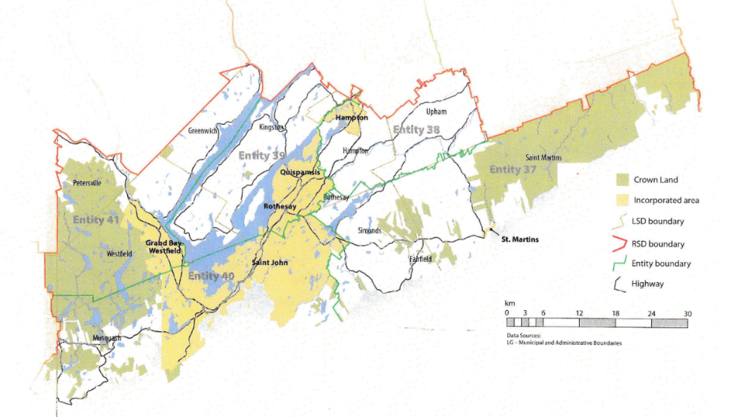
Many of these services, however, would be better served being provided at the regional rather than local level. Rather than leaving some services in the care of the province, the new framework provides Regional Service Districts within which municipalities can collaborate on such basic services as policing, waste management, economic development, and land-use planning. Collaboration on these issues will further reduce cost for services, allowing property tax rates to remain at a reasonable rate.
Entity 37 would belong to RSD 9 along with Entity 38, 39, 40, and 41. As with each municipal entity, RSDs could conceivably be named, but this would be left to each to determine for itself. All entities would be partners in the provision of regional services, with each contributing in accordance with their respective demographic and tax bases.
While this region is perhaps too large to be incorporated into a single municipality, the populations nonetheless have a great deal of shared experiences and challenges. RSD 9 covers portions of both Kings and Saint John counties and the distribution of commuters reflects the economic interdependence within these areas. In Entities 38, 39, and 41 – the proposed entities included in Kings County – the vast majority of commuters are travel outside Kings county to work in Saint John. While 71% of commuters in Kings County travel outside their county of origin, 76% of Entity 37’s commuters leave their own communities but remain within Saint John County. Furthermore, 91% of Entity 40’s commuters work within their own community.
By better enabling municipalities to provide the services their citizens require through cooperation in service provision, the new framework would therefor clarify the distinction between municipal and provincial responsibilities. While today the service provision of roads, animal control, and policing is dependent on whether or not you live in an incorporated or unincorporated local governance entity, in the new framework, all of these services will be provided by the municipal government. When the residents know exactly who is accountable for what, services will improve.
Alternatively, the communities included in RSD 9 could be amalgamated into a specialized Regional Municipality. While not advisable anywhere else in the province, the communities in the greater Saint John area could conceivably be combined into one larger entity considering their pre-existing collaborative service provision and integrated economies.
This hypothetical Regional Municipality would need to be organized in such a way as to offset the dominance of the existing City of Saint John while working to use the collective resources available to the region for the benefit of all. The RM’s population would be nearly twice that of Saint John, with the total population of all other included local governance entities being nearly the same as that of Saint John proper. Accordingly, as with the administrative boundaries proposed in the rest of the new framework, the administrative and ward boundaries of a potential RM of Saint John would need to disregard existing or historic boundaries. Like other contiguous but administratively independent communities around the province, the differences between the communities of the greater Saint John area are exacerbated by the narcissism of minor difference. When attempting to reorganize the wards or administrative subdivisions of the potential RM then, it is important to re-examine which populations actually have the most in common regardless of anachronistic administrative boundaries. For example, the populations of Grand Bay-Westfield and western Saint John along the Westfield Road are far more similar than the populations included in Saint John’s broader “West side.” Organizing new wards and administrative subdivisions along these lines will allow for the creation of new and harmonious community identities and importantly for the populations of the existing communities other than Saint John would help decrease the population center’s dominance of the region’s representative institutions.
Summation
Overall, Entity 37 would allow all residents to enjoy a comparable level of service in correlation with their level of taxation, to feel represented at a local level and have a real say in how their property tax dollars are being spent, and create a municipal entity that is sustainable enough to navigate the demographic and economic challenges of the 21st century.

Finn, 111.
Finn, 90.

