An Image of the Future – Entity 39 and Regional Service District 9
To illustrate the benefits of this new framework, take the example of Entity 39. For the duration of this discussion the municipality shall be referred to as Entity 39, as while the municipality could conceivably adopt the name Kennebecasis, Rothesay, Quispamsis, or Kingston, the naming of the 53 municipal entities remains a task for the citizens of each proposed entity. Leaving the name of each entity undetermined is an important measure for the development of sustainable new municipal identities to compliment those of the existing towns, villages, and LSDs.
Geographic Boundaries
Entity 39 would be comprised of the Towns of Quispamsis and Rothesay, the Kingston LSD, and a portion of the Westfield LSD. The only Crown Lands included in the entity would be in the Kingston LSD. Despite the placement of Entity 38’s boundary lines, the peninsula would still be connected to the rest of the proposed entity by ferry.
Demographic Base
The total population of the municipality would be approximately 33000 people – a population which has remained stable since 2011. In accordance with the Official Languages Act, Entity 39 would not be required to operate bilingually because the Francophone minority is less than 20% of the overall population.
As it stands today, 10% of the proposed entity’s population live in unincorporated areas and are accordingly without representative local government. In addition to the lack of democratic institutions, the lack of incorporated municipal entities means that there is no land use planning to coordinate economic development. Amalgamation into Entity 39 would therefore benefit the residents of the effected LSDs by enabling them to use the resources they possess and control this development through local representative institutions.
In addition, amalgamation would benefit the proposed entity’s existing municipalities’ democratic institutions. While Rothesay’s voter turnout rates in the 2012 and 2016 quadrennial elections have been above the provincial average, they have both been within a point of said average. Quispamsis on the other hand has not reported a voter turnout rate above 40% in 2012 or 2016. Lower voter turnouts make elections less competitive – especially if low voter turnout is habitual. Less competition in turn reduces government accountability.
Voter Turnout by Existing Municipality
Municipality | Voter Participation 2012¹ | Voter Participation 2016²
Rothesay | 48.01% | 44.80%
Quispamsis | 38.71% | 39.40%
1. Elections NB
The solution for the municipalities of proposed Entity 39 is therefore to expand incorporation and suffrage to contiguous LSDs. Expanding the electorate creates a greater competition of interests, leading to better accountability. As has been witnessed in many Rural Communities, voter turnout among previously unincorporated populations is reasonably high, indicating that the inclusion of contiguous unincorporated populations can improve voter turnouts in existing municipalities.
Financial Base
Entity 39 would also have a financial base capable of service provision beyond a simple aggregation of the assessed value of each constituent municipality and LSD. Under the new framework, municipal revenues will come from a combination of equalization payments from the provincial government, municipal property taxes, and other user fees related to services like water and wastewater usage.
Because its population is above 10000, Entity 39 would qualify as a ‘Group B’ municipality. As Entity 38’s assessment base per capita would be greater than the group average, it would not be entitled to an annual equalization grant. Rather, equal opportunity among the 53 municipalities would be guaranteed by its expanded tax warrant. With the tax room transfer from the provincial government to municipal governments included in the proposed new framework, Entity 38’s assessment base of $3,418,055,200 would be able to yield more revenue than it could under the current local governance regime. Equal Opportunity among municipalities remains a priority in the new framework, but the primary guarantor of said equality is now tax warrants rather than equalization payments.
Of course, the tax room transferred from the provincial government does not necessitate that property tax rates will increase by $1.50 per $100 of valuation across Entity 39, nor does it indicate that the entire municipality will operate with one uniform property tax rate. Because Entity 39 would be composed of suburban and rural populations and since the level of local services may vary considerably within the same municipality, existing provisions regarding differentiated tax rates within the same municipality would need to be used. Residents within each municipality should be taxed for the level of services they receive.
As has been seen in many municipalities around the province, municipalities can adopt differing tax rates for different areas under their jurisdiction. For example, while Eel River Crossing’s property tax rate in 2011 was $1.32 per $100, each former LSD had different, lower property tax rates appropriate to their circumstances. Similar situations can be found across the province, with some cities even imposing different tax rates for those inside and outside the urban center. Entity 39 could easily implement a two tiered property tax regime similar to Fredericton and Dieppe where those inside the urban area and those outside are charged substantially different rates.
Overall, then, Entity 39 would have a financial base appropriate to its size and population. With such a financial base, the municipal entity could be as ambitious or cautious in its service provision as its residents please.
Division of Municipal and Provincial Responsibilities
In addition to policing, emergency measures planning, fire prevention and suppression, roads, and garbage disposal, a municipality may choose to enlarge its role and provide a great number of other services. Many municipalities also take responsibility for local arts and culture, parks and recreation, public transportation, and more. Whether or not this sort of expansion is done is entirely up to the residents of Entity 39, and the tax rates of the entity would reflect this level of service.
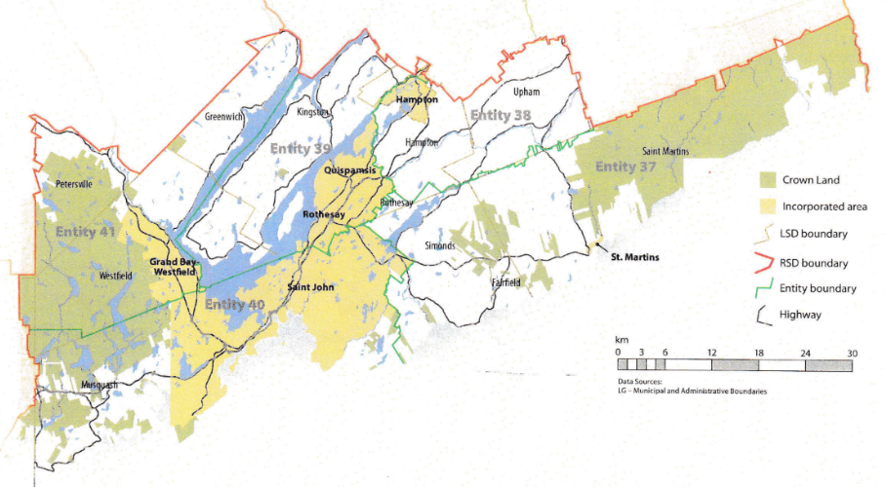
Many of these services, however, would be better served being provided at the regional rather than local level. Rather than leaving some services in the care of the province, the new framework provides Regional Service Districts within which municipalities can collaborate on such basic services as policing, waste management, economic development, and land-use planning. Collaboration on these issues will further reduce cost for services, allowing property tax rates to remain at a reasonable rate.
Entity 39 would belong to RSD 9 along with Entity 39, 39, 40, and 41. As with each municipal entity, RSDs could conceivably be named, but this would be left to each to determine for itself. All entities would be partners in the provision of regional services, with each contributing in accordance with their respective demographic and tax bases.
While this region is perhaps too large to be incorporated into a single municipality, the populations nonetheless have a great deal of shared experiences and challenges. RSD 9 covers portions of both Kings and Saint John counties and the distribution of commuters reflects the economic interdependence within these areas. In Entities 38, 39, and 41 – the proposed entities included in Kings County – the vast majority of commuters are travel outside Kings county to work in Saint John. While 71% of commuters in Kings County travel outside their county of origin, 76% of Entity 39’s commuters leave their own communities but remain within Saint John County. Furthermore, 91% of Entity 40’s commuters work within their own community.
By better enabling municipalities to provide the services their citizens require through cooperation in service provision, the new framework would therefor clarify the distinction between municipal and provincial responsibilities. While today the service provision of roads, animal control, and policing is dependent on whether or not you live in an incorporated or unincorporated local governance entity, in the new framework, all of these services will be provided by the municipal government. When the residents know exactly who is accountable for what, services will improve.
Summation
Overall, Entity 39 would allow all residents to enjoy a comparable level of service in correlation with their level of taxation, to feel represented at a local level and have a real say in how their property tax dollars are being spent, and create a municipal entity that is sustainable enough to navigate the demographic and economic challenges of the 21st century.

Finn, 111.
Finn, 90.

