An Image of the Future – Entity 4 and Regional Service District 1
To illustrate the benefits of this new framework, take the example of Entity 4. For the duration of this discussion the municipality shall be referred to as Entity 4, as while the municipality could conceivably adopt Grand Falls or any other name, the naming of the 53 municipal entities remains a task for the citizens of each proposed entity. Leaving the name of each entity undetermined is an important measure for the development of sustainable new municipal identities to compliment those of the existing towns, villages, and LSDs.
Geographic Boundaries
Entity 4 would be comprised of the Town of Grand Falls/Grand-Saults, the Rural Community of Saint-André, the Village of Drummond, the Drummond Parish LSD, and portions of the Denmark, Lorne, Sainte-Anne, Notre-Dame-de-Lourdes, and Saint-Leonard LSDs. The municipal entity would stretch across Madawaska county, spanning from Restigouche county to the cluster of municipalities near the American border. Notably the boundaries of the proposed entity would not correlate with the old parish lines meaning the population estimates for the following have included only the LSDs and municipalities with a significant portion of their area included in the proposed Entity 4 as the census data is still divided along existing administrative boundaries.
Demographic Base
Voter Turnout by Existing Municipality
Municipality | Voter Participation 2012¹ | Voter Participation 2016
Grand Falls | 73.8% | 70.4%
Saint-André | 67.4% | 68.0%
Drummond | 67.1% | 72.8%
1. Elections NB
The total population of the municipality would be approximately 9000 people. Since 2011 the proposed entity has lost about 6% of its population. In accordance with the Official Languages Act, Entity 4 would not be required to operate bilingually because 84% of the residents are Francophones.
As it stands today, the democratic health of the proposed entity is remarkably positive. All three currently incorporated municipalities have higher than average voter turnouts around the 70% mark, and importantly have had no acclamations in the last two quadrennial election cycles. However, Saint-André has seen frequent by-elections since 2016, indicating a degradation in the community’s potential candidate pool. Because of the optimistic evaluation of the three municipalities, however, the fact that the remaining quarter of the population have no local representative government to speak of is all the more inexcusable.
Status of By-Elections Since 2016
Municipality | 2017 By-Election(s) |  | 2018 By-Election(s) |  | 2019 By-Election(s)
 | Mayor | Councillor | Mayor | Councillor | Mayor | Councillor
Grand Falls | N/A | N/A | N/A | N/A | N/A | N/A
Saint-André | N/A | 2 Acclaimed | Contested | N/A | N/A | N/A
Drummond | N/A | N/A | N/A | N/A | N/A | N/A
1. Elections NB
In addition to providing land use planning and expanded services to the former LSD, incorporating the section of Drummond parish included in the proposed Entity 4 would shore up the entity’s potential candidate pool. The Village of Eel River Crossing provides a good example of how expanding incorporated lands can revive a community’s democratic institutions. In 2014, a number of contiguous LSDs voted to join the nearby village, resulting in a 2015 election which was highly contested. Eel River Crossing’s first election saw 8 candidates compete for 4 at-large councillor positions. Of these 8 candidates, 4 were from previously unincorporated areas.
Financial Base
Entity 4 will also have a financial base capable of service provision beyond a simple aggregation of the assessed value of each constituent municipality and LSD. Under the new framework, municipal revenues will come from a combination of equalization payments from the provincial government, municipal property taxes, and other user fees related to services like water and wastewater usage.
Because its population is below 10000, Entity 4 would qualify as a ‘Group A’ municipality. However, because Entity 4’s property assessment base per capita is higher than its group average, it will not require additional equalization funds to operate effectively. With the tax room transfer from the provincial government to municipal governments included in the proposed new framework, Entity 4’s assessment base of $870 million will be able to yield more revenue than it could today, rendering the need for equalization payments unnecessary. Equal Opportunity among municipalities remains a priority in the new framework, but the primary guarantor of said equality is now tax warrants rather than equalization payments.
Of course, this tax room transfer does not necessitate that property tax rates will increase by $1.50 per $100 of valuation across Entity 4, nor does it indicate that the entire municipality will operate with one uniform property tax rate. Because Entity 4 would be composed of suburban and rural populations and since the level of local services may vary considerably within the same municipality, existing provisions regarding differentiated tax rates within the same municipality would need to be used. Residents within each municipality should be taxed for the level of services they receive.
As has been seen in many municipalities around the province, municipalities can adopt differing tax rates for different areas under their jurisdiction. For example, while Eel River Crossing’s property tax rate in 2011 was $1.32 per $100, each former LSD had different, lower property tax rates appropriate to their circumstances. Similar situations can be found across the province, with some cities even imposing different tax rates for those inside and outside the urban center.
Overall, then, Entity 4 would have a financial base appropriate to its size and population. With such a financial base, the municipal entity could be as ambitious or cautious in its service provision as its residents please.
Division of Municipal and Provincial Responsibilities
In addition to policing, emergency measures planning, fire prevention and suppression, roads, and garbage disposal, a municipality may choose to enlarge its role and provide a great number of other services. Many municipalities also take responsibility for local arts and culture, parks and recreation, public transportation, and more. Whether or not this sort of expansion is done is entirely up to the residents of Entity 4, and the tax rates of the entity would reflect this level of service.
Many of these services, however, would be better served being provided at the regional rather than local level. Rather than leaving some services in the care of the province, the new framework provides Regional Service Districts within which municipalities can collaborate on such basic services as policing, waste management, economic development, and land-use planning. Collaboration on these issues will further reduce cost for services, allowing property tax rates to remain at a reasonable rate.
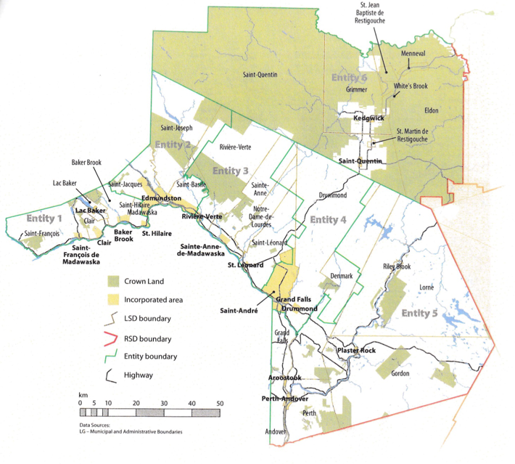
Entity 4 would belong to RSD 1 along with its neighbours Entities 1 to 6, covering Madawaska, Victoria and a portion of Restigouche county. As with each municipal entity, RSDs could conceivably be named, but this would be left to each community to determine for itself. All 6 entities would be partners in the provision of regional services, with each contributing in accordance with their respective demographic and tax bases.
While this region is far too large to be incorporated into a single municipality, the populations nonetheless have a great deal of shared experiences and challenges.
The commuting population of RSD 1 is split between those who commute to work within their own community (46%) those who commute to a different community within the same county (40%), and those commuting to a different county (11%). Entity 4 is of particular interest as it relates to the coherency of the RSD as a whole because of its position at the crossroads of the three effected counties. While smaller than Edmundston, the three communities clustered in Entity 4 nonetheless constitute an economic hub within RSD 1. Accordingly, Entity 4 has the second highest proportion of commuters who remain within their own community for work after Entity 2, the proposed entity which encompasses Edmundston. This role as an economic driver incentivizes further economic interrelation. In addition, however, Entity 4 also has the highest proportion of commuters who travel to a different county for work, with 24% of its commuters presumably travelling to either Madawaska or Restigouche county. These factors both justify the inclusion of all three counties in a single regional entity and highlight the importance of collaboration in economic development and planning for Entity 4 in particular.
The new framework would therefor clarify the distinction between municipal and provincial responsibilities. While today the service provision of roads, animal control, and policing is dependent on whether or not you live in an incorporated or unincorporated local governance entity, in the new framework, all of these services will be provided by the municipal government. When the residents know exactly who is accountable for what, services will improve.
Summation
Overall, Entity 4 would allow its residents to enjoy a comparable level of service in correlation with their level of taxation, to feel represented at a local level and have a real say in how their property tax dollars are being spent, and create a municipal entity that is sustainable enough to navigate the demographic and economic challenges of the 21st century.
Entity 4 : Regional Service District 1
Communities | Entity Type | 2020 Residential Property Assessment | 2020 Non-Residential Property Assessment | 2020 Total Assessment Base | Population 2016 | Population 2011 | % Change
Grand Falls | Town | $355,852,100 | $117,102,700 | $472,954,800 | 5326 | 5706 | -6.66%
Saint-André | Rural Community | $125,815,000 | $42,108,900 | $167,923,900 | 772 | 819 | -5.74%
Drummond | Village | $49,947,300 | $3,302,300 | $53,249,600 | 737 | 775 | -4.90%
Drummond | LSD | $173,402,700 | $3,183,800 | $176,586,500 | 2157 | 2250 | -4.13%
Totals |  | $705,017,100 | $165,697,700 | $870,714,800 | 8992 | 9550 | -5.84%

Finn, 111.
Finn, 90.

