An Image of the Future – Entity 40 and Regional Service District 9
To illustrate the benefits of this new framework, take the example of Entity 40. For the duration of this discussion the municipality shall be referred to as Entity 40, as while the municipality could conceivably adopt the name Saint John, the naming of the 53 municipal entities remains a task for the citizens of each proposed entity. Leaving the name of each entity undetermined is an important measure for the development of sustainable new municipal identities to compliment those of the existing towns, villages, and LSDs.
Geographic Boundaries
Entity 40 would be comprised of the City of Saint John, the Musquash LSD, and a portion of the Simonds LSD.
Demographic Base
The total population of the municipality would be approximately 69000 people – a population which has decreased by 3% since 2011. In accordance with the Official Languages Act, Entity 40 would not be required to operate bilingually because the Francophone minority is less than 20% of the overall population.
As it stands today, the population of Musquash would represent only 1.7% of the overall population of the proposed entity. However, the incorporation of this area would be beneficial for both existing local governance entities. In addition to the lack of democratic institutions, the lack of incorporated municipal entities means that there is no land use planning to coordinate economic development. Amalgamation into Entity 40 would therefore benefit the residents of the effected LSDs by enabling them to use the resources they possess and control this development through local representative institutions.
Voter Turnout by Existing Municipality
Municipality | Voter Participation 2012¹ | Voter Participation 2016²
Saint John | 45.55% | 38.09%
1. Elections NB
In addition, amalgamation would potentially shore up Saint John’s voter turnout rate. Typically, expanding the electorate would foster a greater competition of interests, leading to better accountability and incentivize more regular voter turnout. In this case, however, as the population of Saint John is so large, the effect of the incorporation of Musquash on the voter participation would be negligible at best. Nonetheless, the necessary reassessment of ward boundaries to reflect the municipality’s new size may encourage greater competition =, incentivizing participation.
Financial Base
The primary benefit for Saint John would be the addition of Musquash’s property assessment base. Entity 40 would have a financial base capable of service provision beyond a simple aggregation of the assessed value of each constituent municipality and LSD. Under the new framework, municipal revenues will come from a combination of equalization payments from the provincial government, municipal property taxes, and other user fees related to services like water and wastewater usage.
Because its population is above 40000, Entity 40 would qualify as a ‘Group C’ municipality. However, as Entity 40’s assessment base per capita would be lesser than the group average, it would be entitled to an annual equalization grant of $5,685,897. In addition to this grant, equal opportunity for Entity 40 would be guaranteed by the expanded property tax warrant derived from the property assessment base of $6,499,850,640. While Musquash would represent less than 2% of the overall population of the new Entity 40, it’s assessment base would be almost 6% of the proposed entity’s total assessment base. When broken down into residential and non-residential property assessments, non-residential assessment base would represent 13% of the entity’s total.
Of course, the tax room transferred from the provincial government does not necessitate that property tax rates will increase by $1.50 per $100 of valuation across Entity 40, nor does it indicate that the entire municipality will operate with one uniform property tax rate. Because Entity 40 would be composed of suburban and rural populations and since the level of local services may vary considerably within the same municipality, existing provisions regarding differentiated tax rates within the same municipality would need to be used. Residents within each municipality should be taxed for the level of services they receive.
As has been seen in many municipalities around the province, municipalities can adopt differing tax rates for different areas under their jurisdiction. For example, while Eel River Crossing’s property tax rate in 2011 was $1.32 per $100, each former LSD had different, lower property tax rates appropriate to their circumstances. Similar situations can be found across the province, with some cities even imposing different tax rates for those inside and outside the urban center. If created, Entity 40 could easily implement a two-tiered property tax regime similar to Fredericton and Dieppe where those inside the urban area and those outside are charged substantially different rates.
Overall, then, Entity 40 would have a financial base appropriate to its size and population. With such a financial base, the municipal entity could be as ambitious or cautious in its service provision as its residents please.
Division of Municipal and Provincial Responsibilities
In addition to policing, emergency measures planning, fire prevention and suppression, roads, and garbage disposal, a municipality may choose to enlarge its role and provide a great number of other services. Many municipalities also take responsibility for local arts and culture, parks and recreation, public transportation, and more. Whether or not this sort of expansion is done is entirely up to the residents of Entity 40, and the tax rates of the entity would reflect this level of service.
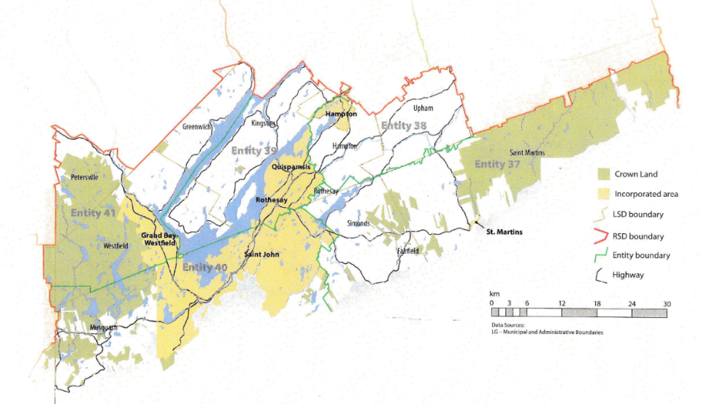
Many of these services, however, would be better served being provided at the regional rather than local level. Rather than leaving some services in the care of the province, the new framework provides Regional Service Districts within which municipalities can collaborate on such basic services as policing, waste management, economic development, and land-use planning. Collaboration on these issues will further reduce cost for services, allowing property tax rates to remain at a reasonable rate.
Entity 40 would belong to RSD 9 along with Entity 40, 39, 40, and 41. As with each municipal entity, RSDs could conceivably be named, but this would be left to each to determine for itself. All entities would be partners in the provision of regional services, with each contributing in accordance with their respective demographic and tax bases.
While this region is perhaps too large to be incorporated into a single municipality, the populations nonetheless have a great deal of shared experiences and challenges. RSD 9 covers portions of both Kings and Saint John counties and the distribution of commuters reflects the economic interdependence within these areas. In Entities 38, 39, and 41 – the proposed entities included in Kings County – the vast majority of commuters are travel outside Kings county to work in Saint John. While 71% of commuters in Kings County travel outside their county of origin, 76% of Entity 40’s commuters leave their own communities but remain within Saint John County. Furthermore, 91% of Entity 40’s commuters work within their own community.
By better enabling municipalities to provide the services their citizens require through cooperation in service provision, the new framework would therefor clarify the distinction between municipal and provincial responsibilities. While today the service provision of roads, animal control, and policing is dependent on whether or not you live in an incorporated or unincorporated local governance entity, in the new framework, all of these services will be provided by the municipal government. When the residents know exactly who is accountable for what, services will improve.
Alternatively, the communities included in RSD 9 could be amalgamated into a specialized Regional Municipality. While not advisable anywhere else in the province, the communities in the Greater Saint John area could conceivably be combined into one larger entity considering their pre-existing collaborative service provision and integrated economies.
This hypothetical Regional Municipality would need to be organized in such a way as to offset the dominance of the existing City of Saint John while working to use the collective resources available to the region for the benefit of all. The RM’s population would be nearly twice that of Saint John, with the total population of all other included local governance entities being nearly the same as that of Saint John proper. Accordingly, as with the administrative boundaries proposed in the rest of the new framework, the administrative and ward boundaries of a potential RM of Saint John would need to disregard existing or historic boundaries. Like other contiguous but administratively independent communities around the province, the differences between the communities of the greater Saint John area are exacerbated by the narcissism of minor difference. When attempting to reorganize the wards or administrative subdivisions of the potential RM then, it is important to re-examine which populations actually have the most in common regardless of anachronistic administrative boundaries. For example, the populations of Grand Bay-Westfield and western Saint John along the Westfield Road are far more similar than the populations included in Saint John’s broader “West side.” Organizing new wards and administrative subdivisions along these lines will allow for the creation of new and harmonious community identities and importantly for the populations of the existing communities other than Saint John would help decrease the population center’s dominance of the region’s representative institutions.
Summation
Overall, Entity 40 would allow all residents to enjoy a comparable level of service in correlation with their level of taxation, to feel represented at a local level and have a real say in how their property tax dollars are being spent, and create a municipal entity that is sustainable enough to navigate the demographic and economic challenges of the 21st century.

Finn, 111.
Finn, 90.

