An Image of the Future – Entity 42 and Regional Service District 10
To illustrate the benefits of this new framework, take the example of Entity 42. For the duration of this discussion the municipality shall be referred to as Entity 42, as while the municipality would presumably adopt the name Grand Manan, the naming of the 53 municipal entities remains a task for the citizens of each proposed entity. Leaving the name of each entity undetermined is an important measure for the development of sustainable new municipal identities to compliment those of the existing towns, villages, and LSDs.
Geographic Boundaries
Entity 42 would be comprised of the both the Village of Grand Manan and the remaining unincorporated portions of the Grand Manan parish. While these boundaries make Entity 42 relatively small in comparison with the other 52 proposed entities, but due to the isolation of the area’s population, including Grand Manan in another, larger entity would not be feasible.
Demographic Base
The total population of the municipality would be approximately 2500 people – a population which has remained stable since 2011. In accordance with the Official Languages Act, Entity 42 would not be required to operate bilingually because the Francophone minority is less than 20% of the overall population.
As it stands today, only 6% of the proposed entity’s population live outside the incorporated portion of the main island. These unincorporated areas’ populations share many of the challenges and circumstances faced by the municipality of Grand Manan, but they are not afforded the same democratic rights. The population of these unincorporated areas also already work exclusively in the village, indicating that the administrative division between the two entities is rather porous and anachronistic. Though an additional 145 people would not have all that significant an impact on the voter turnout rate or potential candidate pool of the proposed entity, it is nonetheless important to address the island’s democratic deficit.
Voter Turnout by Existing Municipality
Municipality | Voter Participation 2012¹ | Voter Participation 2016²
Grand Manan | 66.23% | 53.26%
1. Elections NB
Financial Base
Entity 42 would also have a financial base capable of service provision beyond a simple aggregation of the assessed value of the village and parish. Under the new framework, municipal revenues will come from a combination of equalization payments from the provincial government, municipal property taxes, and other user fees related to services like water and wastewater usage.
Because its population is below 10000, Entity 42 would qualify as a ‘Group A’ municipality. As Entity 42’s assessment base per capita would be greater than the group average, it would not be entitled to an annual equalization grant. Rather, equal opportunity among the 53 municipalities would be guaranteed by its expanded tax warrant. With the tax room transfer from the provincial government to municipal governments included in the proposed new framework, Entity 42’s assessment base of $196,863,100 would be able to yield more revenue than it could under the current local governance regime. Equal Opportunity among municipalities remains a priority in the new framework, but the primary guarantor of said equality is now tax warrants rather than equalization payments.
Of course, the tax room transferred from the provincial government does not necessitate that property tax rates will increase by $1.50 per $100 of valuation across Entity 42, nor does it indicate that the entire municipality will operate with one uniform property tax rate. Because Entity 42 would be composed of suburban and rural populations and since the level of local services may vary considerably within the same municipality, existing provisions regarding differentiated tax rates within the same municipality would need to be used. Residents within each municipality should be taxed for the level of services they receive.
As has been seen in many municipalities around the province, municipalities can adopt differing tax rates for different areas under their jurisdiction. For example, while Eel River Crossing’s property tax rate in 2011 was $1.32 per $100, each former LSD had different, lower property tax rates appropriate to their circumstances. Similar situations can be found across the province, with some cities even imposing different tax rates for those inside and outside the urban center. If created, Entity 42 could easily implement a multi-tiered property tax regime similar to Fredericton and Dieppe where those inside the urban area and those outside are charged substantially different rates.
Overall, then, Entity 42 would have a financial base appropriate to its size and population. With such a financial base, the municipal entity could be as ambitious or cautious in its service provision as its residents please.
Division of Municipal and Provincial Responsibilities
In addition to policing, emergency measures planning, fire prevention and suppression, roads, and garbage disposal, a municipality may choose to enlarge its role and provide a great number of other services. Many municipalities also take responsibility for local arts and culture, parks and recreation, public transportation, and more. Whether or not this sort of expansion is done is entirely up to the residents of Entity 42, and the tax rates of the entity would reflect this level of service.
Many of these services, however, would be better served being provided at the regional rather than local level. Rather than leaving some services in the care of the province, the new framework provides Regional Service Districts within which municipalities can collaborate on such basic services as policing, waste management, economic development, and land-use planning. Collaboration on these issues will further reduce cost for services, allowing property tax rates to remain at a reasonable rate.
Entity 42 would belong to RSD 10 along with Entities 43, 44, 45, snd 46. As with each municipal entity, RSDs could conceivably be named, but this would be left to each to determine for itself. All entities would be partners in the provision of regional services, with each contributing in accordance with their respective demographic and tax bases.
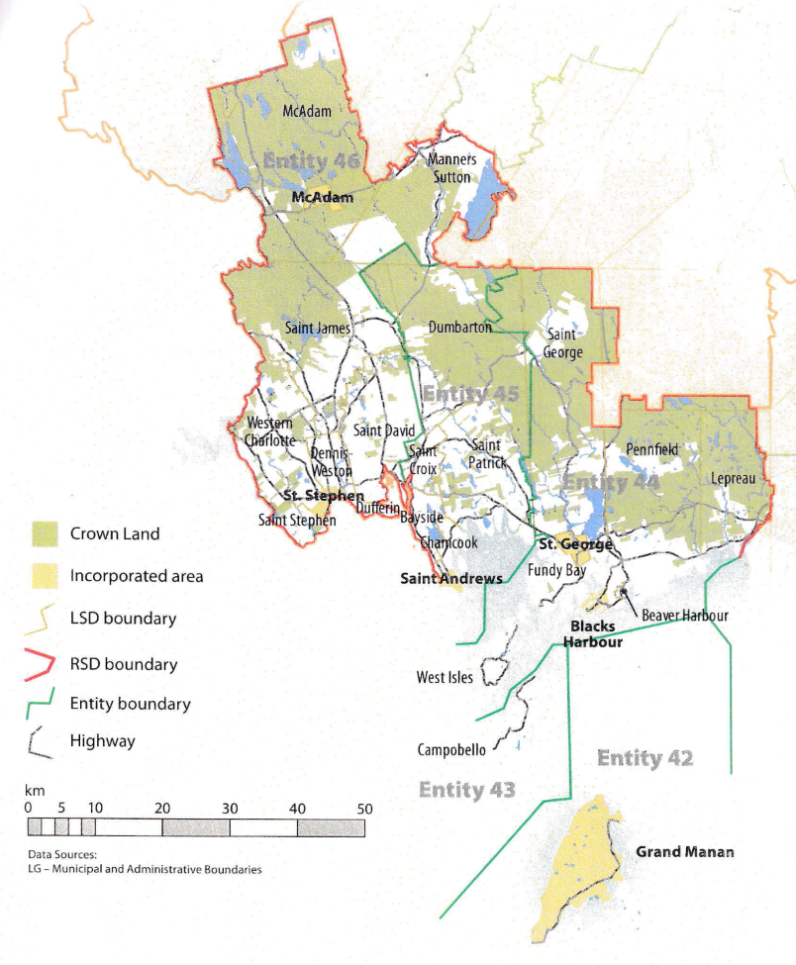
While this region is too large to be incorporated into a single municipality, the populations nonetheless have a great deal of shared experiences and challenges. RSD 10 covers portions of both Charlotte and York counties and the distribution of commuters reflects the economic interdependence within these areas. Unlike the other 11 RSDs, however, two of RSD 9’s constituent entities have overwhelming majorities of commuters who remain within their communities as the island communities of Campobello and Grand Manan are relatively self-contained. Typically only urban centers report such a level of commuter retention, but given the exceptional circumstances of island communities, these numbers can be regarded as exceptional.
That being said, the commuting populations of the three other included entities see over half of their workers leave their respective communities to work in another part of their county of origin. Such numbers illustrate the need for further collaborative economic planning to reflect the interconnected economies of these communities.
By better enabling municipalities to provide the services their citizens require through cooperation in service provision, the new framework would therefor clarify the distinction between municipal and provincial responsibilities. While today the service provision of roads, animal control, and policing is dependent on whether or not you live in an incorporated or unincorporated local governance entity, in the new framework, all of these services will be provided by the municipal government. When the residents know exactly who is accountable for what, services will improve.
Summation
Overall, Entity 42 would allow all residents to enjoy a comparable level of service in correlation with their level of taxation, to feel represented at a local level and have a real say in how their property tax dollars are being spent, and create a municipal entity that is sustainable enough to navigate the demographic and economic challenges of the 21st century.

Finn, 111.
Finn, 90.

