An Image of the Future – Entity 48 and Regional Service District 11
To illustrate the benefits of this new framework, take the example of Entity 48. For the duration of this discussion the municipality shall be referred to as Entity 48, as while the municipality could conceivably adopt the name Cambridge-Narrows, Minto, or Chipman, the naming of the 53 municipal entities remains a task for the citizens of each proposed entity. Leaving the name of each entity undetermined is an important measure for the development of sustainable new municipal identities to compliment those of the existing towns, villages, and LSDs.
Geographic Boundaries
Entity 48 would be comprised of the Villages of Cambridge-Narrows, Chipman, and Minto, and the Cambridge, Waterborough, Chipman, Northfield, Sheffield, and Maugerville LSDs. The majority of the entity’s landmass would be Crown Lands, with inhabited areas being concentrated around major roadways.
Demographic Base
The total population of the municipality would be approximately 15000 people – a decrease of 4% from 2011. In accordance with the Official Languages Act, Entity 48 would not be required to operate bilingually because the Francophone minority is less than 20% of the overall population.
As it stands today, 62% of the proposed entity’s population live in unincorporated areas and are accordingly without representative local government. In addition to the lack of democratic institutions, the lack of incorporated municipal entities means that there is no land use planning to coordinate economic development. Amalgamation into Entity 48 would therefore benefit the residents of the effected LSDs by enabling them to use the resources they possess and control this development through local representative institutions.
In addition, amalgamation would benefit the proposed entity’s existing municipalities’ democratic institutions. While the three existing municipalities have all reported voter turnout rates near 70% over the course of the previous decade, there is also substantial instability in these communities. Cambridge-Narrows had nearly three quarters of its population participate in the 2012 quadrennial election, but in 2016 no ballots were cast because there was not enough candidates to allow for a contested election. Similarly, Minto’s two by-elections for mayoral and council positions were
Voter Turnout by Existing Municipality
Municipality | Voter Participation 2012¹ | Voter Participation 2016
Cambridge-Narrows | 74.1% | acclaimed
Chipman | 44.2% | 68.0%
Minto | 68.9% | 71.5%
1. Elections NB
decided by acclamation in 2018. Such high voter turnout and frequent acclamations indicate that while the electorate is engaged the potential candidate pools of Cambridge-Narrows and Minto are contracting as the overall population decreases. While less quantifiable than voter participation, the resilience of a community’s potential candidate pool is just as important an indicator of a municipality’s overall democratic health.
In Chipman, however, the problem is slightly different. Though voter participation in 2016 was comparable to the other municipalities in the area, the 2012 election results were far lower. This discrepancy of over 20 points indicates a need for a more competitive electorate to ensure more regular voter participation.
Status of By-Elections for Mayors and/or Councillors
Municipality | 2018 By-Election(s)
 | Mayor | Councillor
Cambridge-Narrows | N/A | N/A
Chipman | N/A | N/A
Minto | Acclaimed | Acclaimed
1. Elections NB
The solution for the municipalities of proposed Entity 48 is therefore to expand incorporation and suffrage to contiguous LSDs. Expanding the electorate creates a greater competition of interests, leading to better accountability. As has been witnessed in many Rural Communities, voter turnout among previously unincorporated populations is reasonably high, indicating that the inclusion of contiguous unincorporated populations can improve voter turnouts in existing municipalities. Additionally, the amalgamation of the existing municipalities and incorporation of contiguous populations in LSDs will allow for the development of a more robust candidate pool. Provided that new ward boundaries are designed well, the incorporation of previously excluded populations can have a very beneficial effect on the competitiveness of local elections. An example of such a strategy succeeding can be observed in the Village of Eel River Crossing. In 2014, a number of contiguous LSDs voted to join the nearby village, resulting in a 2015 election which was highly contested. Eel River Crossing’s first election saw 8 candidates compete for 4 at-large councillor positions. Of these 8 candidates, 4 were from previously unincorporated areas. Because the population of these LSDs represent just less than half of the proposed entity’s total population, enabling their participation as both voters and candidates will give Entity 48 a better chance at developing healthy and sustainable democratic institutions.
Financial Base
Entity 48 would also have a financial base capable of service provision beyond a simple aggregation of the assessed value of each constituent municipality and LSD. Under the new framework, municipal revenues will come from a combination of equalization payments from the provincial government, municipal property taxes, and other user fees related to services like water and wastewater usage.
Because its population is above 10000, Entity 48 would qualify as a ‘Group B’ municipality. As Entity 48’s assessment base per capita would be lesser than the group average, it would be entitled to an annual equalization grant of $380,138 to ensure equal opportunity among the 53 municipal entities. With the tax room transfer from the provincial government to municipal governments included in the proposed new framework, Entity 48’s assessment base of $789,954,550 would be able to yield more revenue than it could under the current local governance regime. Equal Opportunity among municipalities remains a priority in the new framework, but the primary guarantor of said equality is now tax warrants rather than equalization payments.
Of course, the tax room transferred from the provincial government does not necessitate that property tax rates will increase by $1.50 per $100 of valuation across Entity 48, nor does it indicate that the entire municipality will operate with one uniform property tax rate. Because Entity 48 would be composed of suburban and rural populations and since the level of local services may vary considerably within the same municipality, existing provisions regarding differentiated tax rates within the same municipality would need to be used. Residents within each municipality should be taxed for the level of services they receive.
As has been seen in many municipalities around the province, municipalities can adopt differing tax rates for different areas under their jurisdiction. For example, while Eel River Crossing’s property tax rate in 2011 was $1.32 per $100, each former LSD had different, lower property tax rates appropriate to their circumstances. Similar situations can be found across the province, with some cities even imposing different tax rates for those inside and outside the urban center. Entity 48 could easily implement a two tiered property tax regime similar to Fredericton and Dieppe where those inside the urban area and those outside are charged substantially different rates.
Overall, then, Entity 48 would have a financial base appropriate to its size and population. With such a financial base, the municipal entity could be as ambitious or cautious in its service provision as its residents please.
Division of Municipal and Provincial Responsibilities
In addition to policing, emergency measures planning, fire prevention and suppression, roads, and garbage disposal, a municipality may choose to enlarge its role and provide a great number of other services. Many municipalities also take responsibility for local arts and culture, parks and recreation, public transportation, and more. Whether or not this sort of expansion is done is entirely up to the residents of Entity 48, and the tax rates of the entity would reflect this level of service. Many of these services, however, would be better served being provided at the regional rather than local level. Rather than leaving some services in the care of the province, the new framework provides Regional Service Districts within which municipalities can collaborate on such basic services as policing, waste management, economic development, and land-use planning. Collaboration on these issues will further reduce cost for services, allowing property tax rates to remain at a reasonable rate.
Entity 48 would belong to RSD 11 along with Entities 47, 49, and 50. As with each municipal entity, RSDs could conceivably be named, but this would be left to each to determine for itself. All entities would be partners in the provision of regional services, with each contributing in accordance with their respective demographic and tax bases.
While this region is too large to be incorporated into a single municipality, the populations nonetheless have a great deal of shared experiences and challenges. RSD 11 covers portions of York, Queens, and Sunbury counties and the distribution of commuters reflects the economic interdependence within these areas. Entity 50, which is entirely contained within York county, has 77% of its commuters leave their own communities but remain within the county. Likewise, the portions of the other three proposed entities not included in York county travel outside their counties of origins for work. The only exception in this regard is Entity 48 which does support a significant group of commuters who remain within their own communities in Sunbury county. Overall, however, the economies of the four entities of RSD 11 are dependent on the economic hub of Fredericton proper. In addition to lower costs associated with shared regional services, this regional cooperation will therefore also allow for further collaborative economic planning to reflect the interconnected economies of these communities.
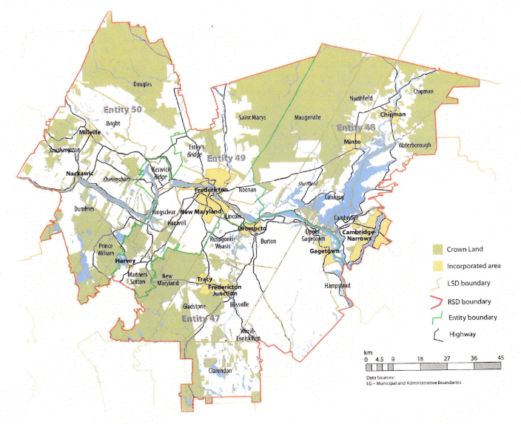
By better enabling municipalities to provide the services their citizens require through cooperation in service provision, the new framework would therefor clarify the distinction between municipal and provincial responsibilities. While today the service provision of roads, animal control, and policing is dependent on whether or not you live in an incorporated or unincorporated local governance entity, in the new framework, all of these services will be provided by the municipal government. When the residents know exactly who is accountable for what, services will improve.
Summation
Overall, Entity 48 would allow all residents to enjoy a comparable level of service in correlation with their level of taxation, to feel represented at a local level and have a real say in how their property tax dollars are being spent, and create a municipal entity that is sustainable enough to navigate the demographic and economic challenges of the 21st century.

Finn, 111.
Finn, 90.

