An Image of the Future – Entity 51 and Regional Service District 12
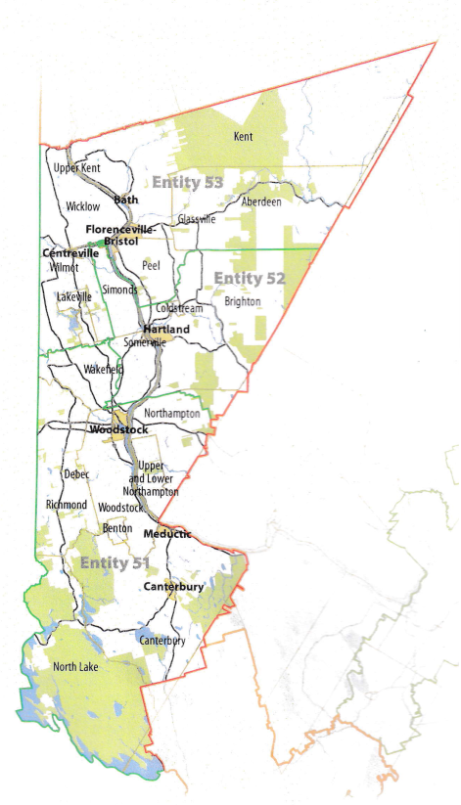
To illustrate the benefits of this new framework, take the example of Entity 51. For the duration of this discussion the municipality shall be referred to as Entity 51, as while the municipality could conceivably adopt Meductic, Woodstock, Canterbury, or any other name, the naming of the 53 municipal entities remains a task for the citizens of each proposed entity. Leaving the name of each entity undetermined is an important measure for the development of sustainable new municipal identities to compliment those of the existing towns, villages, and LSDs.
Geographic Boundaries
Entity 51 would be comprised of the Town of Woodstock, the Villages of Canterbury and Meductic, and the North Lake, Benton, Woodstock, Richmond, Debec, Upper and Lower Northampton, Northampton, and a portion of Wakefield LSDs. The municipal entity would stretch across the bottommost corner of Carleton county and include a section of York county. Save for the North Lake area, the proposed entity would not include much Crown Land.
Demographic Base
The total population of the municipality would be approximately 14800 people, down from 15200 in 2011. In accordance with the Official Languages Act, Entity 51 would not be required to operate bilingually because less than 20% of the residents are Francophones.
As it stands today, the democratic health of the proposed entity is deteriorating. The majority of the inhabitants of the proposed Entity 51 currently live in unincorporated areas and are accordingly without local representative government. The Village of Meductic has not been able to field enough candidates to have contested elections in either the 2012 or 2016, effectively depriving the inhabitants of the village of their ability to vote. Woodstock had the lowest and third lowest voter turnout rates in the 2012 and 2016 quadrennial elections respectively. Canterbury, while still reporting a higher than average voter turnout rate in 2016 and seeing an increase in population, has nonetheless seen a significant drop in voter participation between 2012 and 2016.
By amalgamating into the proposed Entity 51, the size of the electorate would increase significantly, and so too would the interests at stake in quadrennial elections. Especially in previously unincorporated areas, the threat of property tax increases in accordance with increased services is a powerful negative incentive for voting. These conflicting interests increase competition, incentivize voter participation and cultivate healthy democratic institutions. As is evident in the province’s three largest cities’ voter participation rates (all below 40%), increase in the size of the electorate is only beneficial to a certain extent. With a population of less than 15000, however, it can be expected that an increase in the size of the electorate would be beneficial.
Voter Turnout by Existing Municipality
Municipality | Voter Participation 2012¹ | Voter Participation 2016
Canterbury | 61.6% | 59.6%
Meductic | acclaimed | acclaimed
Woodstock | 28.7% | 28.4%
1. Elections NB
The growth of the electorate also serves to renew the pool of potential candidates needed to maintain competitive elections. An example of such a strategy succeeding can be observed in the Village of Eel River Crossing. . In 2014, a number of contiguous LSDs voted to join the nearby village, resulting in a 2015 election which was highly contested. Eel River Crossing’s first election saw 8 candidates compete for 4 at-large councillor positions. Of these 8 candidates, 4 were from previously unincorporated areas. Because the population of these LSDs represent over half of the proposed entity’s total population, enabling their participation as both voters and candidates will give Entity 51 a better chance at developing healthy and sustainable democratic institutions.
Financial Base
Entity 51 will also have a financial base capable of service provision beyond a simple aggregation of the assessed value of each constituent municipality and LSD. Under the new framework, municipal revenues will come from a combination of equalization payments from the provincial government, municipal property taxes, and other user fees related to services like water and wastewater usage.
Because its population is above 10000, Entity 51 would qualify as a ‘Group B’ municipality. As Entity 51’s assessment base per capita would be greater than the group average, it would not be entitled to an annual equalization grant. Rather, equal opportunity among the 53 municipalities would be guaranteed by its expanded tax warrant. With the tax room transfer from the provincial government to municipal governments included in the proposed new framework, Entity 51’s assessment base of $1,084,239,450 would be able to yield more revenue than it could under the current local governance regime. Equal Opportunity among municipalities remains a priority in the new framework, but the primary guarantor of said equality is now tax warrants rather than equalization payments.
Of course, this tax room transfer does not necessitate that property tax rates will increase by $1.50 per $100 of valuation across Entity 51, nor does it indicate that the entire municipality will operate with one uniform property tax rate. Because Entity 51 would be composed of suburban and rural populations and since the level of local services may vary considerably within the same municipality, existing provisions regarding differentiated tax rates within the same municipality would need to be used. Residents within each municipality should be taxed for the level of services they receive.
As has been seen in many municipalities around the province, municipalities can adopt differing tax rates for different areas under their jurisdiction. For example, while Eel River Crossing’s property tax rate in 2011 was $1.32 per $100, each former LSD had different, lower property tax rates appropriate to their circumstances. Similar situations can be found across the province, with some cities even imposing different tax rates for those inside and outside the urban center. Entity 51 could easily implement a two tiered property tax regime similar to Fredericton and Dieppe where those inside the urban area and those outside are charged substantially different rates.
Overall, then, Entity 51 would have a financial base appropriate to its size and population. With such a financial base, the municipal entity could be as ambitious or cautious in its service provision as its residents please.
Division of Municipal and Provincial Responsibilities
In addition to policing, emergency measures planning, fire prevention and suppression, roads, and garbage disposal, a municipality may choose to enlarge its role and provide a great number of other services. Many municipalities also take responsibility for local arts and culture, parks and recreation, public transportation, and more. Whether or not this sort of expansion is done is entirely up to the residents of Entity 51, and the tax rates of the entity would reflect this level of service.
Many of these services, however, would be better served being provided at the regional rather than local level. Rather than leaving some services in the care of the province, the new framework provides Regional Service Districts within which municipalities can collaborate on such basic services as policing, waste management, economic development, and land-use planning. Collaboration on these issues will further reduce cost for services, allowing property tax rates to remain at a reasonable rate.
Entity 51 would belong to RSD 12 along with its neighbours Entities 52 and 53, covering Carleton county and the western portion of York county. As with each municipal entity, RSDs could conceivably be named, but this would be left to each to determine for itself. All 3 entities would be partners in the provision of regional services, with each contributing in accordance with their respective demographic and tax bases.
While this region is far too large to be incorporated into a single municipality, the populations nonetheless have a great deal of shared experiences and challenges. 63% of commuters travel out of their own community every day, but remain within their own county, indicating a high level of economic interconnectivity in RSD 12.
The only exception in this regard is Entity 51. Entity 51 has a slightly lower rate of commuters travelling within their own county because it includes a portion of York county. In Canterbury, Canterbury Parish, Meductic, and North Lake, 48% of commuters travel outside of their own county for work, representing the plurality of commuters in these communities. These exceptional numbers reinforce the importance of creating RSDs and municipal entities which deviate from traditional and anachronistic administrative boundaries.
The new framework would therefor clarify the distinction between municipal and provincial responsibilities. While today the service provision of roads, animal control, and policing is dependent on whether or not you live in an incorporated or unincorporated local governance entity, in the new framework, all of these services will be provided by the municipal government. When the residents know exactly who is accountable for what, services will improve.
Summation
Overall, Entity 51 would allow all residents of the province’s northern panhandle to enjoy a comparable level of service in correlation with their level of taxation, to feel represented at a local level and have a real say in how their property tax dollars are being spent, and create a municipal entity that is sustainable enough to navigate the demographic and economic challenges of the 21st century.

Finn, 111.
Finn, 90.

