An Image of the Future – Entity 7 and Regional Service District 2
To illustrate the benefits of this new framework, take the example of Entity 7, the municipality roughly equivalent with the greater Campbellton area. For the duration of this discussion the municipality shall be referred to as Entity 7, as while the municipality could conceivably adopt the name Campbellton or any other name, the naming of the 53 municipal entities remains a task for the citizens of each entity. Leaving the name of each entity undetermined is an important measure for the development of sustainable new municipal identities to compliment those of the existing towns, villages, and LSDs.
Entity 7 is a logical example to begin with because of its history. While once a prosperous city, Campbellton and the surrounding area has gradually dwindled, with current populations falling well below the official requirement for recognition as a city. Prior to the 2008 Finn report, a 1997 consultation had already determined that the amalgamation of Campbellton, Atholville, and Tidehead was the optimal solution for the area going forward as it would promote self-sufficiency, sustainability, and foster economic and social well-being. Since then the need for amalgamation has only increased as the populations of all three communities have further decreased.
Furthermore, in recent years some communities initially described as part of Entity 7 have amalgamated of their own volition, demonstrating the desire for this sort of reform. As a result of plebiscites during the 2014 municipal byelections, Val D’Amour, St. Arthur, and a portion of Blair Athol became part of the Village of Atholville and a portion of the McLoeds LSD joined the Village of Eel River. Both plebiscites passed with significant majorities.
Geographic Boundaries
In addition to Campbellton, Atholville, and Tidehead, Entity 7 would also include the local service districts of Flatlands, Glencoe, Mann Mountain, McLeods, and Addington parish, as well as significant stretches of the Eldon parish and Balmoral parish. While a great deal of the entity’s landmass would be Crown Land, the coastal region could be considered continuously – albeit at times sparsely – inhabited.
Entity 7’s northern coastal boundary would extend from McLeods in the East to Mann Mountain in the West. South from Mann Mountain, the boundary would parallel the parish line, but run approximately two kilometers further West than the existing boundary between the Eldon and Addington LSDs. The southern boundary would follow the Addington Parish lines, as would the eastern boundary. However, like the western boundary, the eastern line would run approximately four kilometers eastward of its original position into Balmoral parish. Overall, modification to the historical parish boundaries in this case attempts to limit panhandles, as would be the case with Atholville, Val D’Amours, and Blair Atholville in relation to Balmoral Parish’s historical boundary.
Demographic Base
The total population of the municipality would be approximately 12,400 – down from 13,000 in 2011. In accordance with the Official Languages Act, Entity 10 would be required to operate bilingually because one third of the population are anglophones. This official bilingual designation is fitting especially because the most populated areas, Campbellton and Atholvill,e are relatively evenly split between French and English speaking populations.
The unification of the populations of the continue to communities would also improve the state of local democratic institutions. The recent amalgamations of contiguous LSDs into the village of Atholville significantly increased the number of residents capable of voting in local elections, but approximately 1000 residents within the boundaries of Entity 7 are still experiencing a democratic deficit. In accordance with the aims of the new framework, these residents will be guaranteed the right to self-governance at the local level in Entity 7, but the increase in overall population will also enable more competitive municipal elections for rural and urban populations alike. Even with recent amalgamations, Atholville’s 2015 election still saw a councillor elected by acclamation. A municipality as large as Entity 7 would have a greater pool of candidates to draw from to prevent elections by acclamation, making for more competitive elections and more accountable representatives.
Financial Base
Entity 7 will also have a financial base capable of service provision beyond a simple aggregation of the assessed value of each constituent municipality and LSD. Under the new framework, municipal revenues will come from a combination of equalization payments from the provincial government, municipal property taxes, and other user fees related to services like water and wastewater usage.
Because Entity 7 would have a population between 10,000 and 40,000, it would be considered a Group B municipality. Accordingly, because its property assessment base per capita is lesser than the group average, the entity would receive an annual equalization grant of $872,048 to ensure equal opportunity among municipal entities. With the tax room transfer from the provincial government to municipal governments included in the proposed new framework, Entity 7’s assessment base of $896,088,300 would also be able to yield more revenue than it could under the current local governance regime. Equal Opportunity among municipalities remains a priority in the new framework, but the primary guarantor of said equality is now tax warrants rather than equalization payments.

Beyond this unconditional grant, however, Entity 7 will have additional revenue raising power. Of course, this tax room transfer does not necessitate that property tax rates will increase by $1.50 per $100 of valuation across Entity 7, nor does it indicate that the entire municipality will operate with one universal property tax rate. Because Entity 7 would be composed of urban, suburban and rural populations and since the level of local services may vary considerably within the same municipality, existing provisions regarding differentiated tax rates within the same municipality would need to be used. Residents within each municipality should be taxed for the level of services they receive.
As has been seen in many municipalities around the province, municipalities can adopt differing tax rates for different areas under their jurisdiction. For example, in 2014 four LSDs merged with the neighboring Village of Eel River Crossing. While the town’s tax property tax rate in 2018 was $1.32 per $100, each former LSD had different, lower property tax rates appropriate to their circumstances. Similar situations can be found across the province, with some cities even imposing different tax rates for those inside and outside the urban center. As the communities within Entity 7 move forward together, it is entirely possible that each former local governance entity maintain their own respective property tax regimes, though strict adherence to such a scheme would fail to take advantage of the opportunities offered by their amalgamation.
Overall, then, Entity 7 would have a financial base appropriate to its size and population. With such a financial base, the municipal entity could be as ambitious or cautious in its service provision as its residents please.
Division of Municipal and Provincial Responsibilities
In addition to policing, emergency measures planning, fire prevention and suppression, roads, and garbage disposal, a municipality may choose to enlarge its role and provide a great number of other services. Many municipalities also take responsibility for local arts and culture, parks and recreation, public transportation, and more. Whether or not this sort of expansion is done is entirely up to the residents of Entity 7, and the tax rates of the entity would reflect this level of service.
Many of these services, however, would be better served being provided at the regional rather than local level. Rather than leaving some services in the care of the province, the new framework provides Regional Service Districts within which municipalities can collaborate on such basic services as policing, waste management, economic development, and land-use planning. Collaboration on these issues will further reduce cost for services, allowing property tax rates to remain at a reasonable rate.
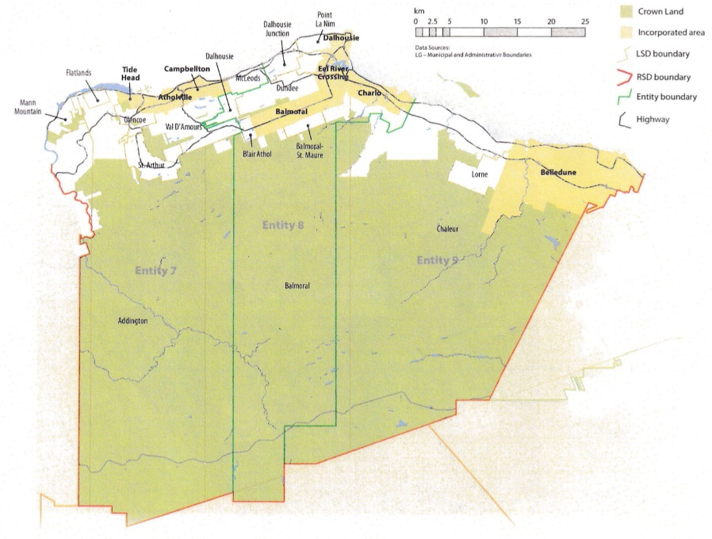
Entity 7 would belong to RSD 2 along with its neighbours Entities 8 & 9. These entities are roughly equivalent to the areas surrounding Dalhousie and Belledune, and the RSD covers an area comparable to the historical Restigouche County. As with each municipal entity, RSDs could conceivably be named, but this would be left to each community to determine for itself. Entity 8 would belong to RSD 2 along with its neighbours Entities 7 and 9. These entities are roughly equivalent to the areas surrounding Campbellton and Belledune, and the RSD covers an area comparable to the historical Restigouche County. As with each municipal entity, RSDs could conceivably be named, but this would be left to each community to determine for itself. All three entities would be equal partners in the provision of regional services, with each contributing in accordance with their respective demographic and tax bases.
While this region is far too large to be incorporated into a single municipality, the populations nonetheless have a great deal of shared experiences and challenges. While only 3% of residents commute to a different region for work and 34% work within their own community, a staggering 58% of residents commute to a different community within RSD 2, indicating a remarkable level of economic interdependence. The RSD can therefore help address common economic and service-related challenges without compromising the self-governance of any contingent entity.
Overall, the new framework would clarify the distinction between municipal and provincial responsibilities. While today the service provision of roads, animal control, and policing is dependent on whether or not you live in an incorporated or unincorporated local governance entity, in the new framework, all of these services will be provided by the municipal government. When the residents know exactly who is accountable for what, services will improve.
Summation
Overall, Entity 7 would allow all residents of the Campbellton area to enjoy a comparable level of service in correlation with their level of taxation, to feel represented at a local level and have a real say in how their property tax dollars are being spent, and create a municipal entity that is sustainable enough to navigate the demographic and economic challenges of the 21st century.

Finn, 181.
Finn, 87.
Finn, 90.

