An Image of the Future – Entity 9 and Regional Service District 2
To illustrate the benefits of this new framework, take the example of Entity 9, the municipality stretching from Belledune to Charlo. For the duration of this discussion the municipality shall be referred to as Entity 9, as while the municipality could conceivably adopt Belledune, Lorne, Chaleaur or any other name, the naming of the 53 municipal entities remains a task for the citizens of each entity. Leaving the name of each entity undetermined is an important measure for the development of sustainable new municipal identities to compliment those of the existing towns, villages, and LSDs.
Geographic Boundaries
While covering a large area, Entity 9 would consist of only four existing local governance entities. The only village currently within the boundaries of Entity 9 is Belledune, with the rest of the area covered by the LSDs of Lorne, Colburne, and Durham. The majority of the entity would be Crown Land.
Entity 9’s northern boundary would follow the coastline from the edge of Charlo through to the end of Belledune. Its western, southern, and eastern boundaries would then follow the parish lines. The eastern boundary, however, would not run along but parallel the Balmoral parish line, sitting approximately 4 kms eastward of the historical parish line.
Demographic Base
The total population of the municipality would be approximately 1,400 – down from 1,500 in 2011. Entity 9 would not be required to operate bilingually because less than 20% of the population are francophones.
The unification of the populations of Entity 9 communities would improve the state of local democratic institutions. When amalgamations or annexations are proposed, it is often the more sparsely populated areas who fear becoming tyrannized by the whims of larger population centres should they lose their independence. Likewise, bigger population centres fear allocating disproportionate influence to small rural adjuncts. While both fears are legitimate, neither appreciate the significant benefit to self-governance that a larger and more diverse population can bring. The mutual desire to be given fair representation is a major impetus for voter participation. Belledune already has a remarkable voter turnout rate of 72%. It is conceivable that if given the vote, the surrounding communities may follow the example of their neighbours – especially when motivated by the threat of being governed at the whim of a more urban population.
There is precedent for recently incorporated areas reporting higher than average voter turnout rates which help keep elections competitive, representative, and accountable. The relatively novel Rural Communities, being given a representative local government for the first time since the 1960s, have reported higher than average voter turnout rates with the exceptions of Hanwell and Campobello. The average rate across all 7 communities was 55.42%, but the highest among the class, Kedgwick, had a turnout rate of 73.69%! It could be anticipated, therefore, that the currently unincorporated areas of Entity 8 would bring a good deal of competition to the municipality’s elections, guaranteeing a vibrant democratic community.
Financial Base
Entity 9 will also have a financial base capable of service provision beyond a simple aggregation of the assessed value of each constituent municipality and LSD. Under the new framework, municipal revenues will come from a combination of equalization payments from the provincial government, municipal property taxes, and other user fees related to services like water and wastewater usage.
Because its population is below 10000, Entity 9 would qualify as a ‘Group A’ municipality. Accordingly, because its property assessment base per capita is greater than the group average, the entity would not receive an annual equalization grant. With the tax room transfer from the provincial government to municipal governments included in the proposed new framework, Entity 9’s assessment base of $385,385,800 would be able to yield more revenue than it could under the current local governance regime. Equal Opportunity among municipalities remains a priority in the new framework, but the primary guarantor of said equality is now tax warrants rather than equalization payments.
Of course, this tax room transfer does not necessitate that property tax rates will increase by $1.50 per $100 of valuation across Entity 9, nor does it indicate that the entire municipality will operate with one universal property tax rate. Because Entity 9 would be composed of suburban and rural populations and since the level of local services may vary considerably within the same municipality, existing provisions regarding differentiated tax rates within the same municipality would need to be used. Residents within each municipality should be taxed for the level of services they receive.
As has been seen in many municipalities around the province, municipalities can adopt differing tax rates for different areas under their jurisdiction. For example, while Eel River Crossing’s property tax rate in 2018 was $1.32 per $100, each former LSD had different, lower property tax rates appropriate to their circumstances. Similar situations can be found across the province, with some cities even imposing different tax rates for those inside and outside the urban center. As the communities within Entity 9 move forward together, it is entirely possible that each former local governance entity maintain their own respective property tax regimes, though strict adherence to such a scheme would fail to take advantage of the opportunities offered by their amalgamation.
Overall, then, Entity 9 would have a financial base appropriate to its size and population. With such a financial base, the municipal entity could be as ambitious or cautious in its service provision as its residents please.
Division of Municipal and Provincial Responsibilities
In addition to policing, emergency measures planning, fire prevention and suppression, roads, and garbage disposal, a municipality may choose to enlarge its role and provide a great number of other services. Many municipalities also take responsibility for local arts and culture, parks and recreation, public transportation, and more. Whether or not this sort of expansion is done is entirely up to the residents of Entity 9, and the tax rates of the entity would reflect this level of service.
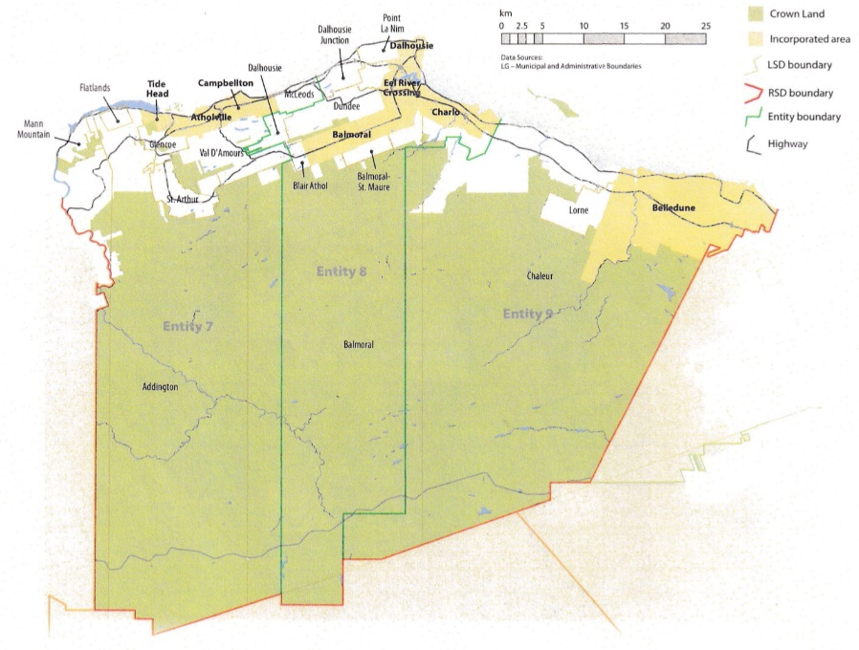
Many of these services, however, would be better served being provided at the regional rather than local level. Rather than leaving some services in the care of the province, the new framework provides Regional Service Districts within which municipalities can collaborate on such basic services as policing, waste management, economic development, and land-use planning. Collaboration on these issues will further reduce cost for services, allowing property tax rates to remain at a reasonable rate.
Entity 9 would belong to RSD 2 along with its neighbours Entities 7 and 8. These entities are roughly equivalent to the areas surrounding Campbellton and Dalhousie, and the RSD covers an area comparable to the historical Restigouche County. As with each municipal entity, RSDs could conceivably be named, but this would be left to each community to determine for itself. All three entities would be equal partners in the provision of regional services, with each contributing in accordance with their respective demographic and tax bases.
While this region is far too large to be incorporated into a single municipality, the populations nonetheless have a great deal of shared experiences and challenges. While only 3% of residents commute to a different region for work and 34% work within their own community, a staggering 58% of residents commute to a different community within RSD 2, indicating a remarkable level of economic interdependence. Despite the presence of the Belledune power generation station, 50% of the area’s labour force still commutes to a different part of the RSD for work.
Given that in LSDs most of these services are provided by the province, in transitioning to the new framework a few exceptions need to be addressed. While the responsibility for roads typically falls under the mandate of municipalities, the vast stretches of rural regional road placed under the jurisdiction of the 53 new municipal entities would potentially undermine their financial independence. Accordingly, while the incorporation of the Lorne, Colbourne, and Durham LSDs would bring 40 kms of roads which were previously cared for by the province under the jurisdiction of Entity 9, only roads classified as local will be cared for by the municipality. Accordingly, the 4 kms of regional roads would remain the responsibility of the province while Entity 9 would assume control of the 36 kms of local roads.
Overall, however, the new framework would clarify the distinction between municipal and provincial responsibilities. While today the service provision of roads, animal control, and policing is dependent on whether or not you live in an incorporated or unincorporated local governance entity, in the new framework, all of these services will be provided by the municipal government. When the residents know exactly who is accountable for what, services will improve.
Summation
Overall, Entity 9 would allow all residents of the Belledune area to enjoy a comparable level of service in correlation with their level of taxation, to feel represented at a local level and have a real say in how their property tax dollars are being spent, and create a municipal entity that is sustainable enough to navigate the demographic and economic challenges of the 21st century. However, since 2008 the population of the area has decreased dramatically, falling below the minimum requirement for a municipal entity under the proposed framework. The only other proposed entities with populations smaller than 4000 are the island communities of Campobello and Grand Manan, and these exceptions are due to their isolation from other population centres. Entity 9 would still have a property assessment base well above the recommended minimum of $200,000,000 which is why its assessment base per capita is so much greater than the Group A average, but such a small population may still be cause enough for a reimagining of the entity’s boundaries.

Finn, 181.
Finn, 90.

